TASK 1

1. Finger Printing Webserver

Wappalyzer

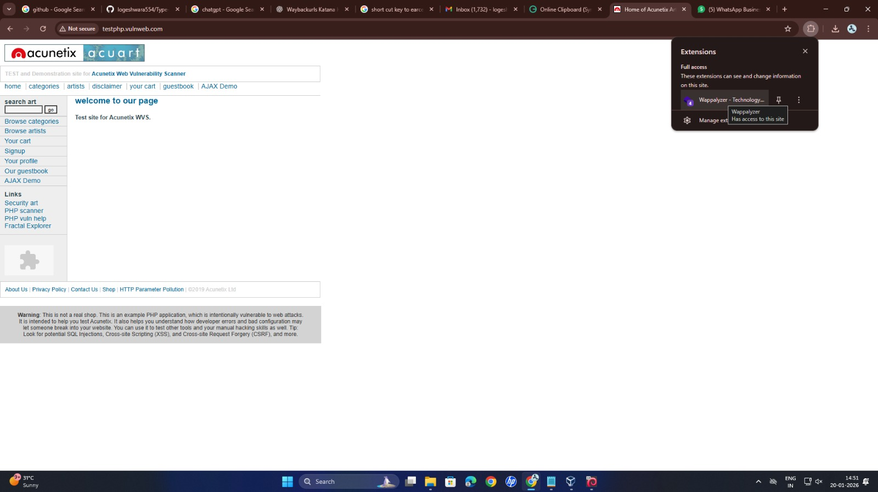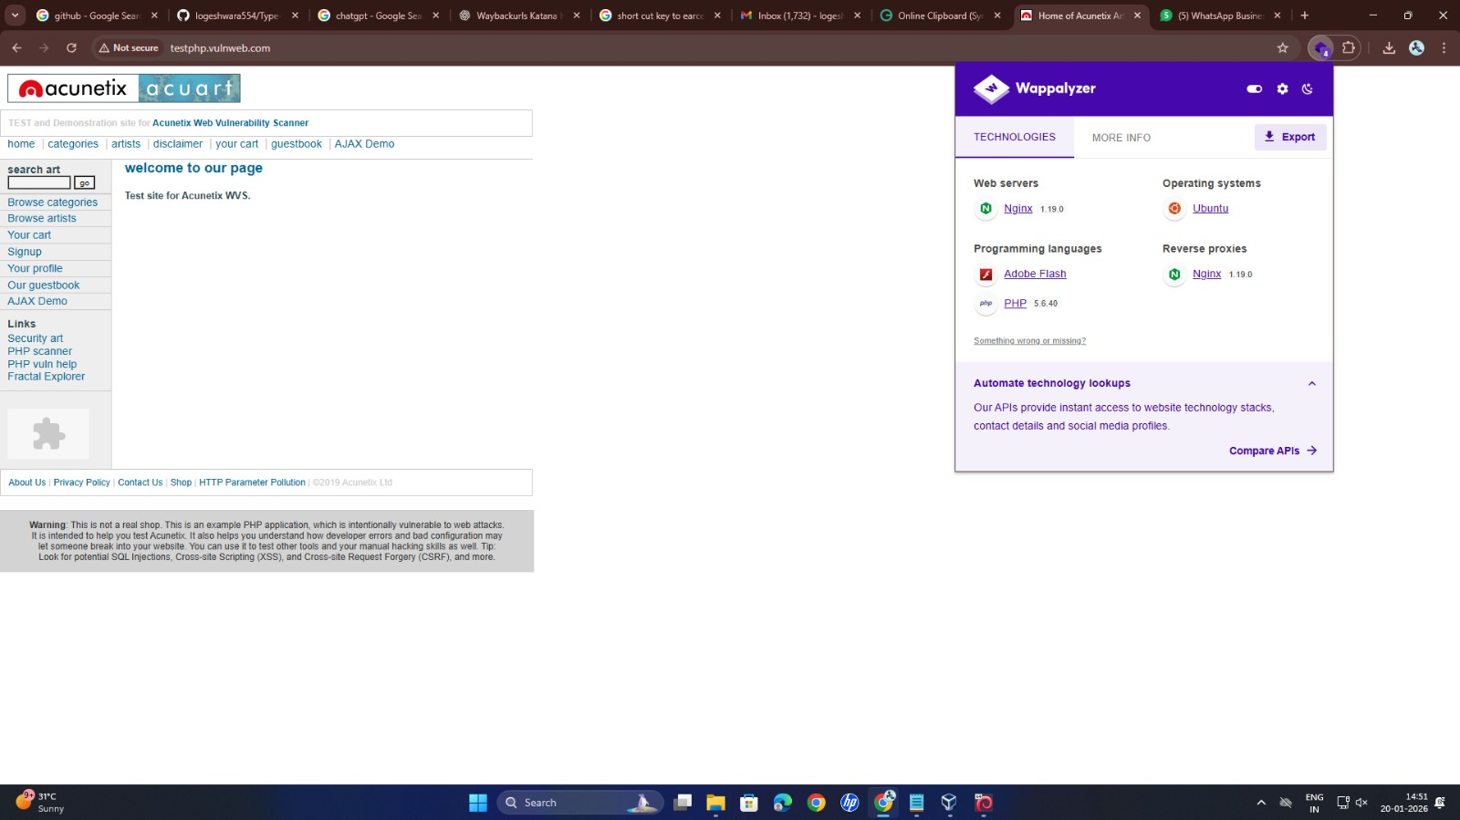

1. Peform Google Dorks Search

site:example.com – all pages

site:example.com filetype:pdf – PDF files

site:example.com filetype:xls – Excel files

site:example.com inurl:admin – admin page

site:example.com intitle:login – login page

site:example.com inurl:backup – backup files

site:example.com inurl:config – config files

site:example.com "index of" – open folders

site:example.com inurl:test – test pages

site:example.com inurl:dev – dev pages

site:example.com inurl:upload – upload folders

site:example.com filetype:txt – text files

site:example.com filetype:log – log files

site:example.com "password" – password keyword

site:example.com "api_key" – API key keyword

site:example.com inurl:db – database pages

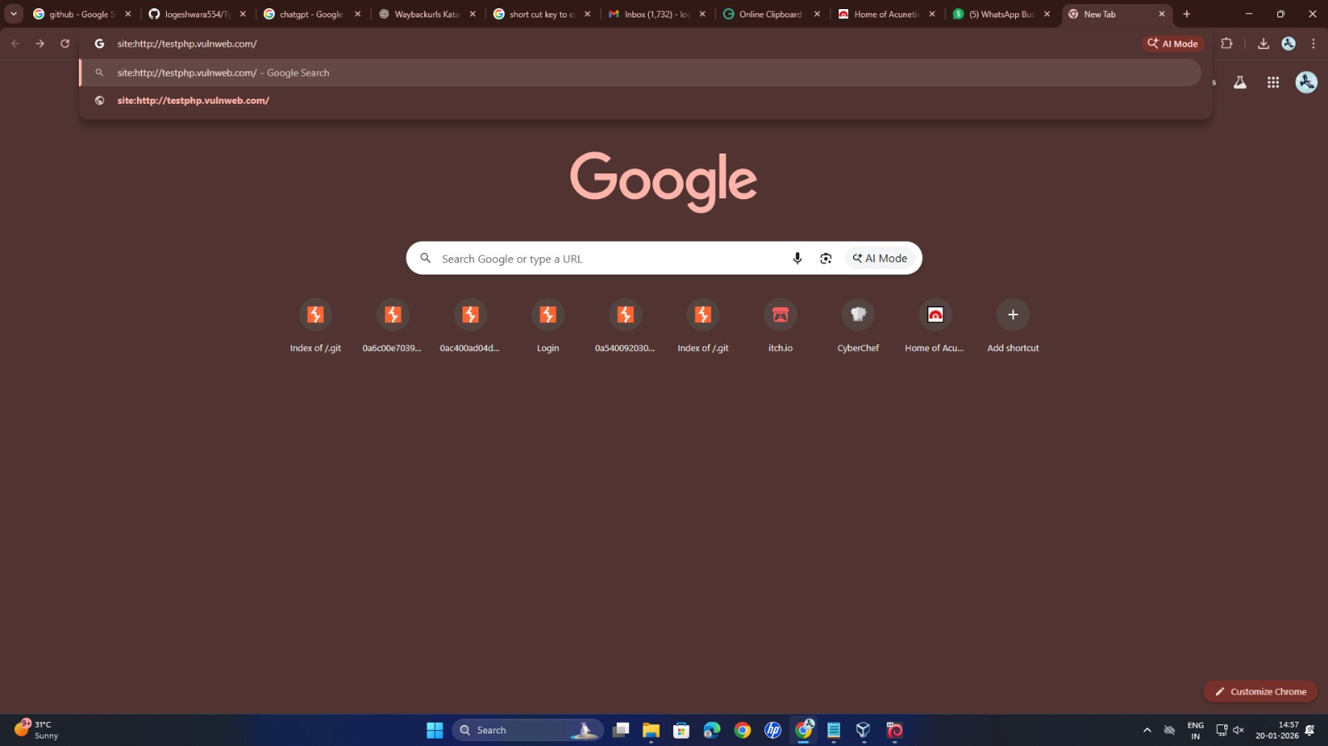

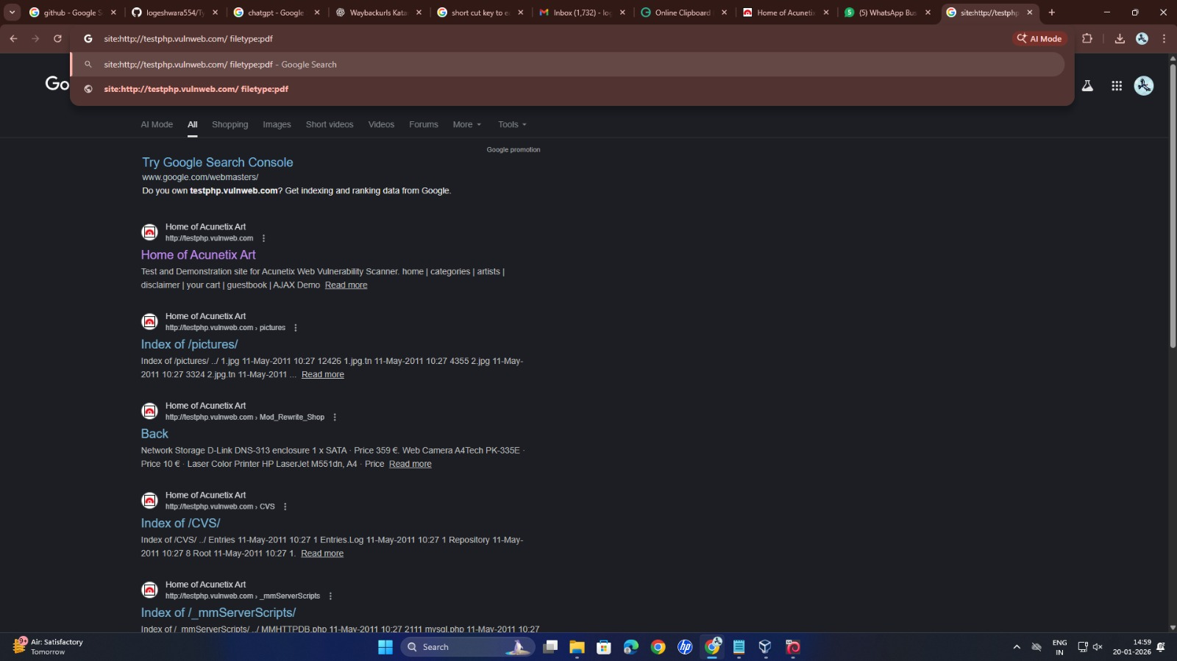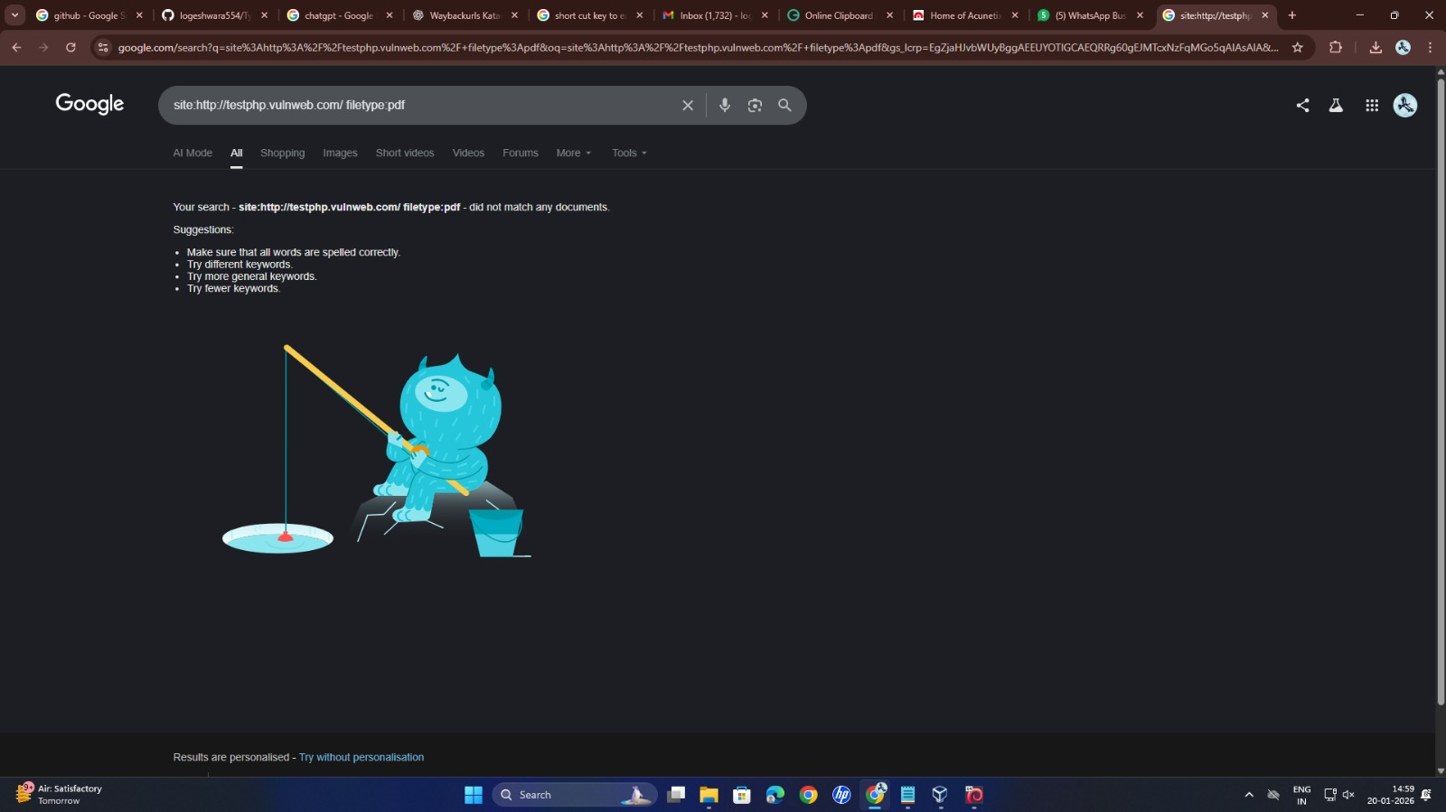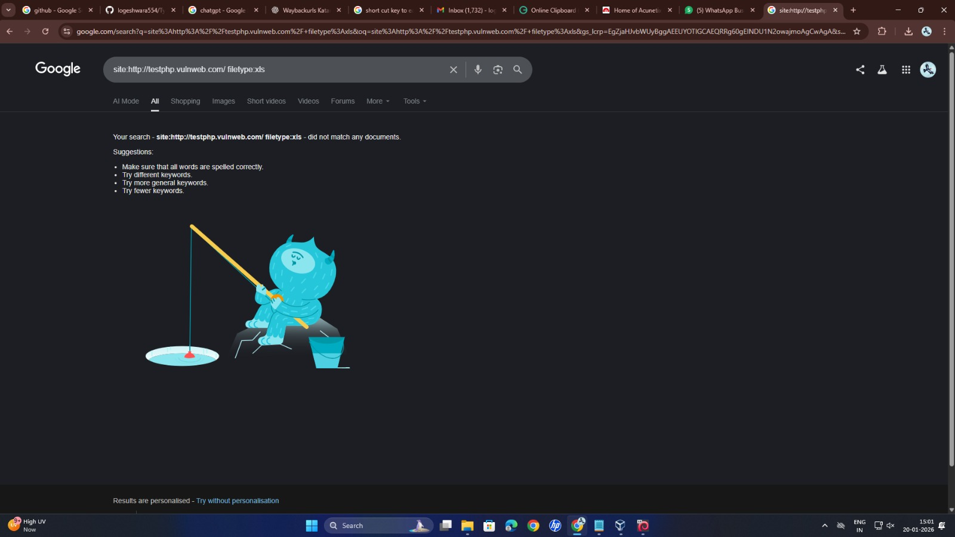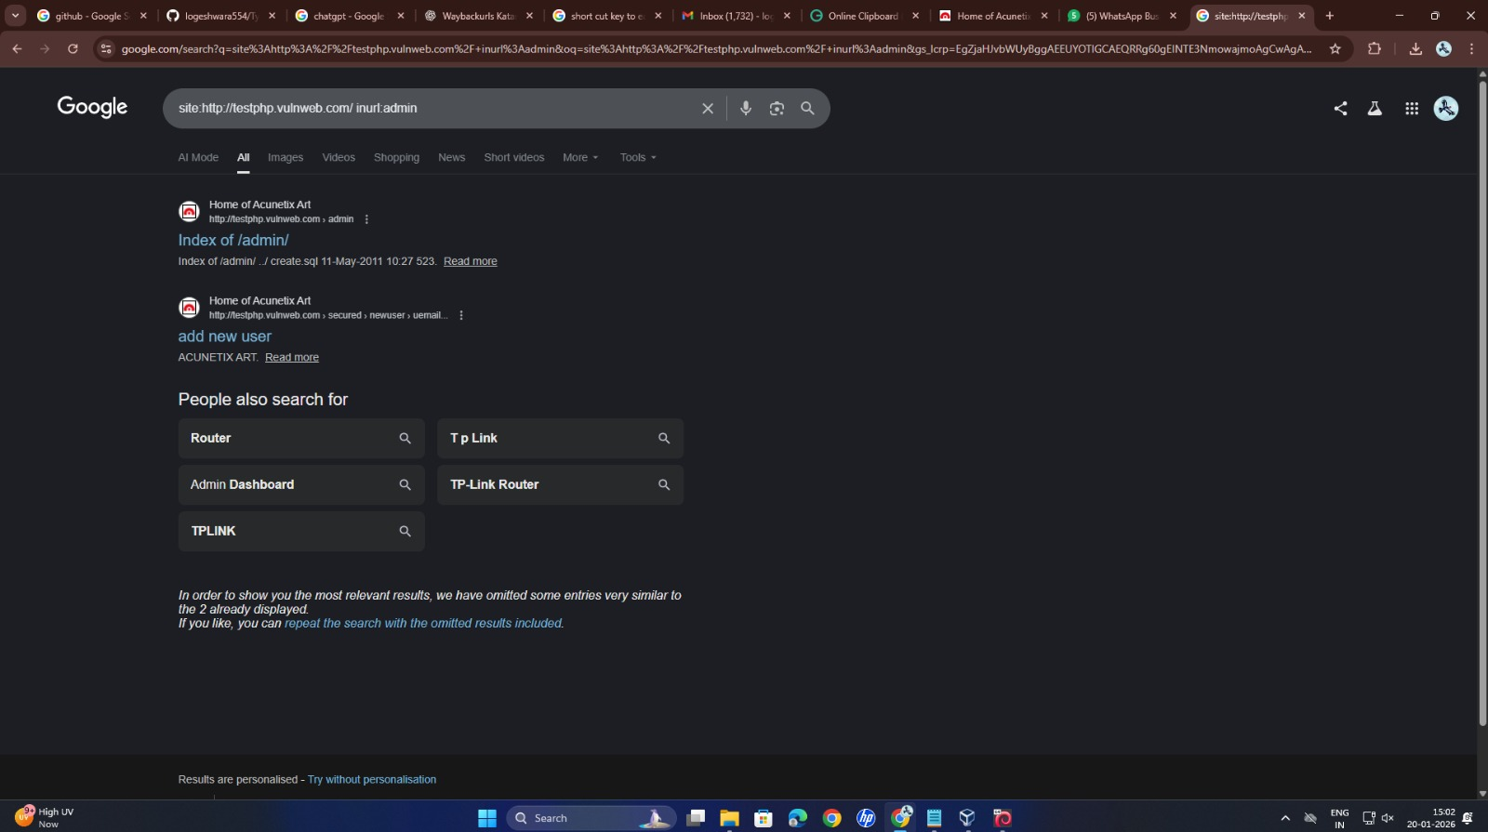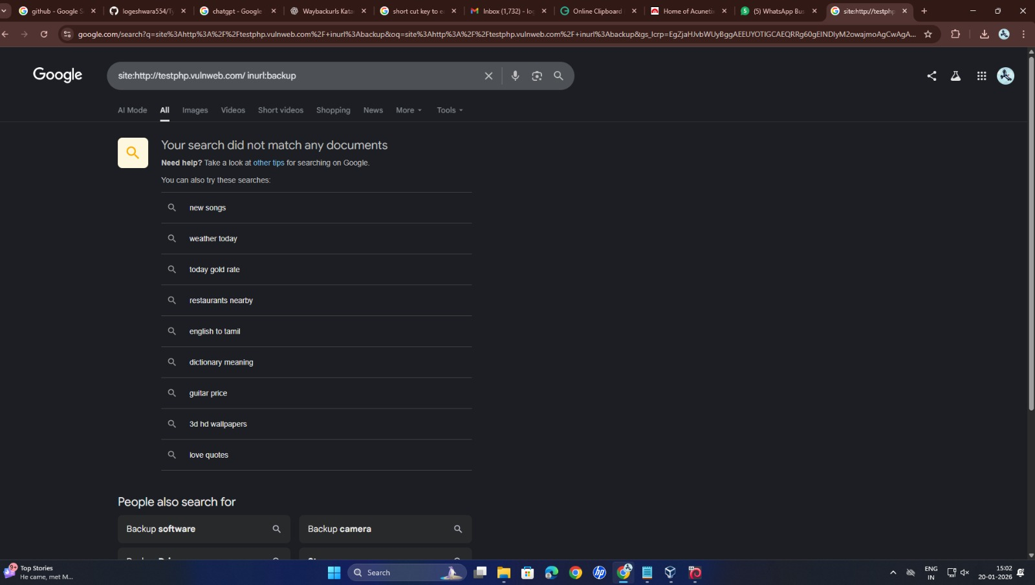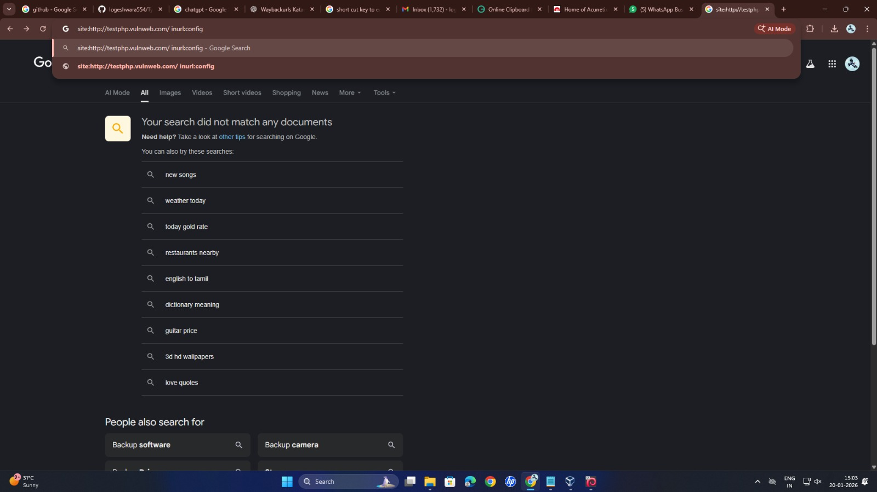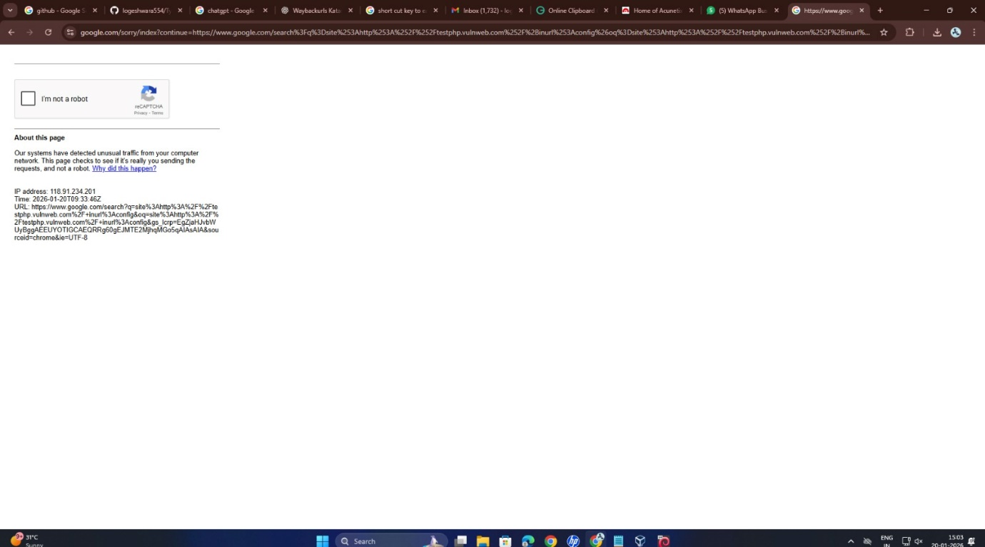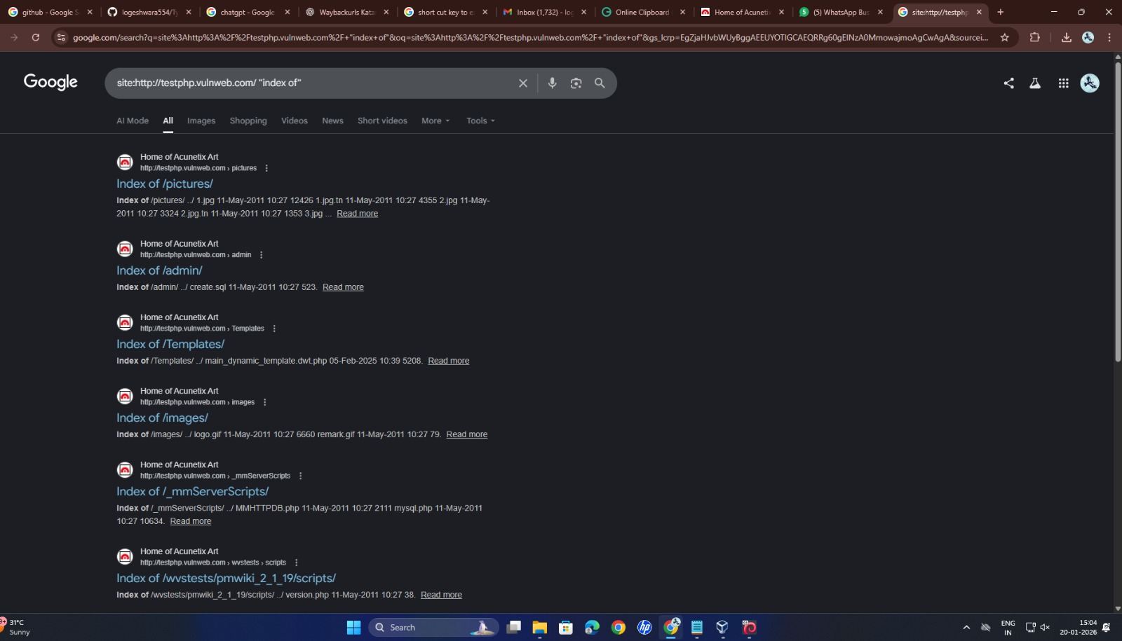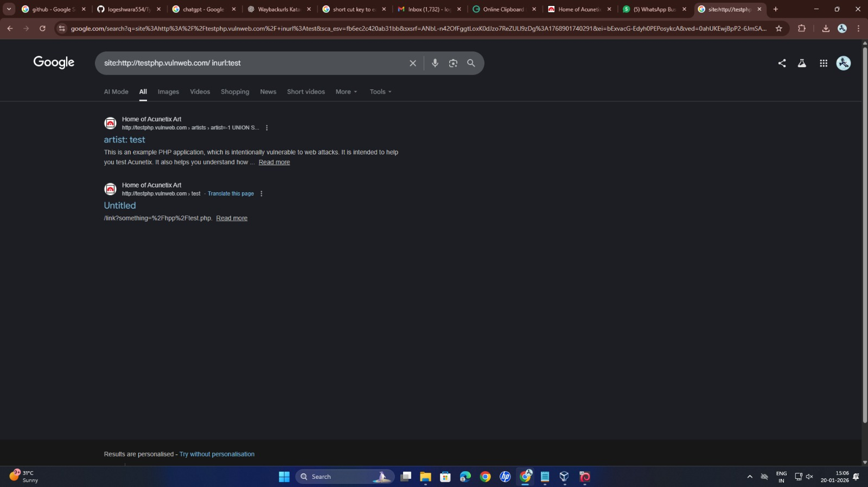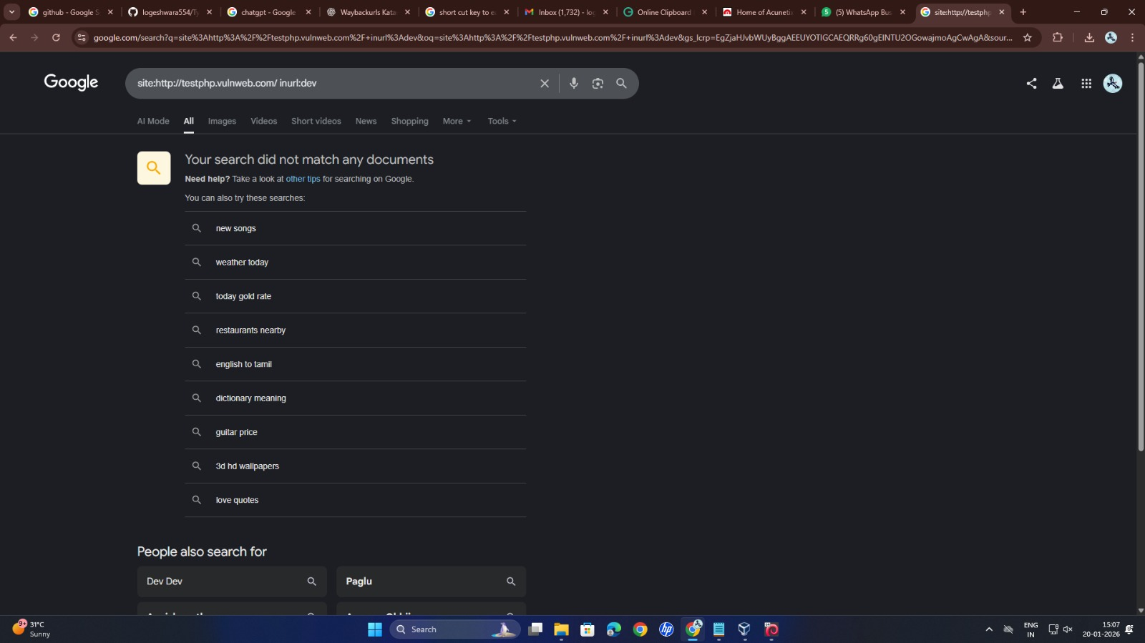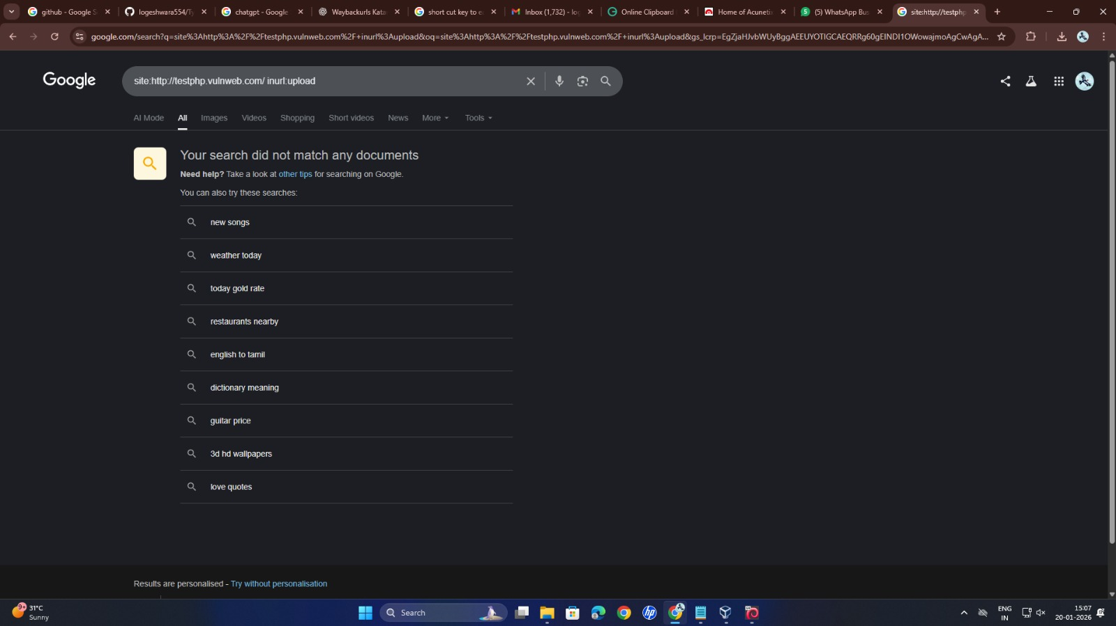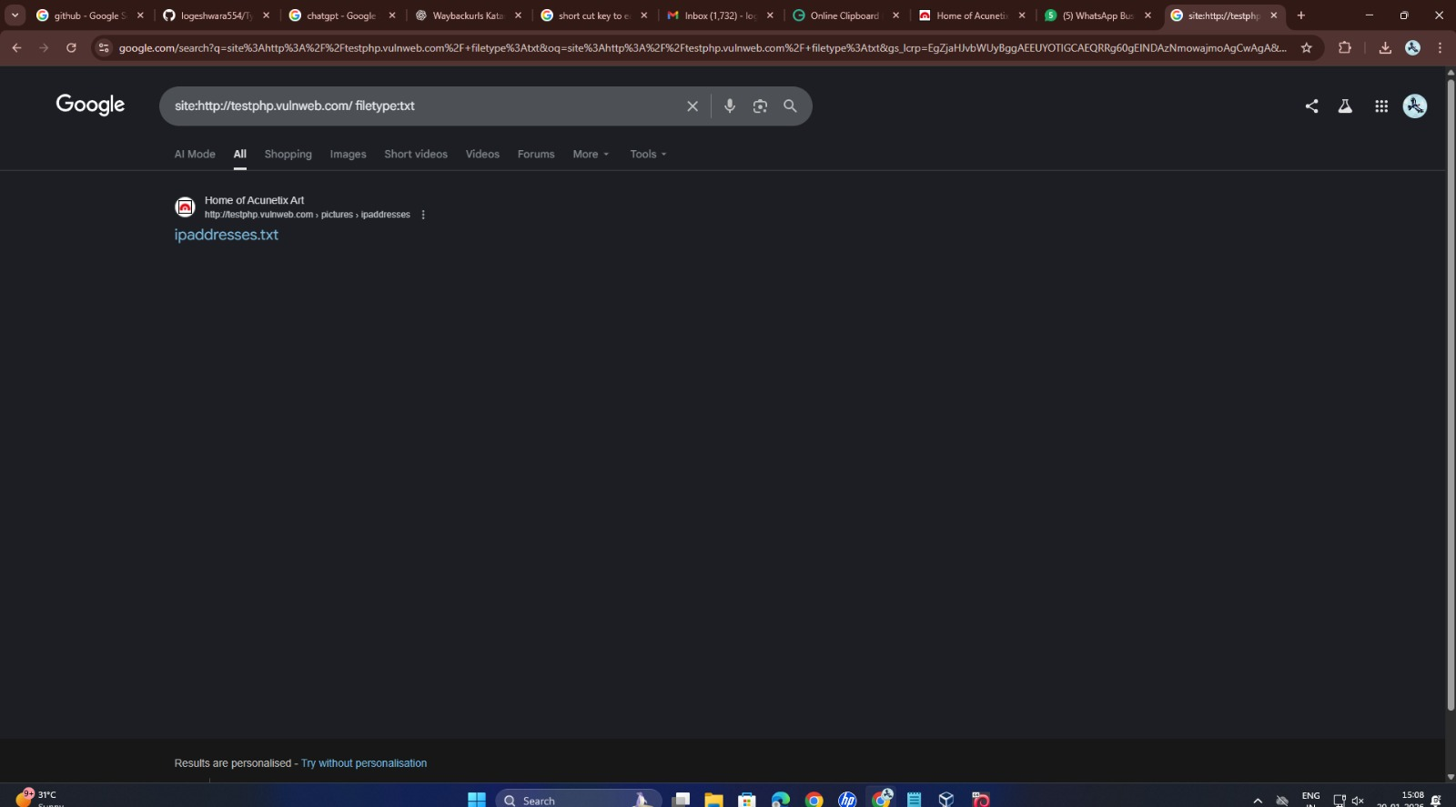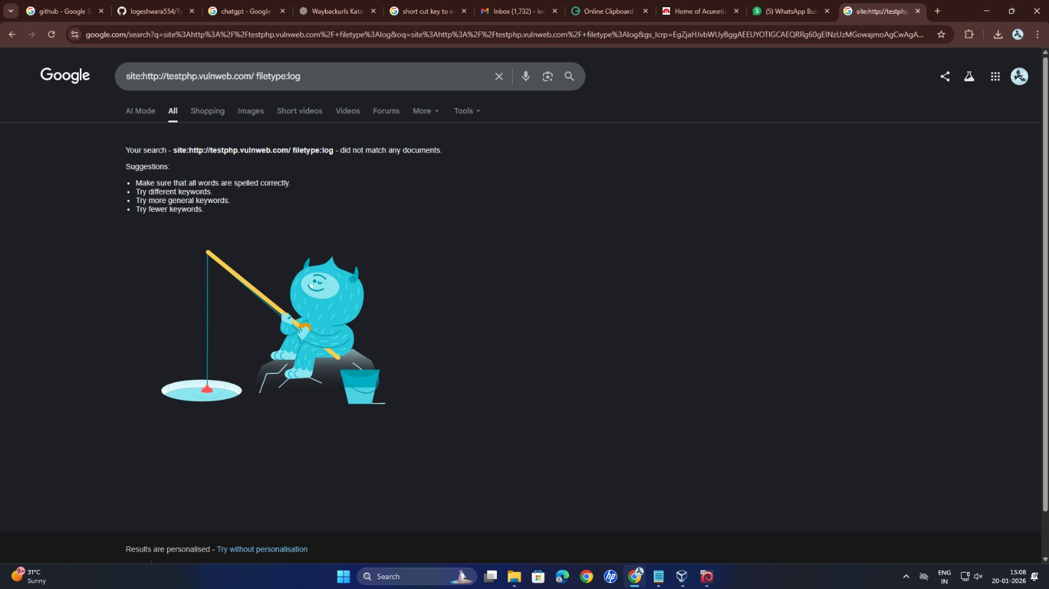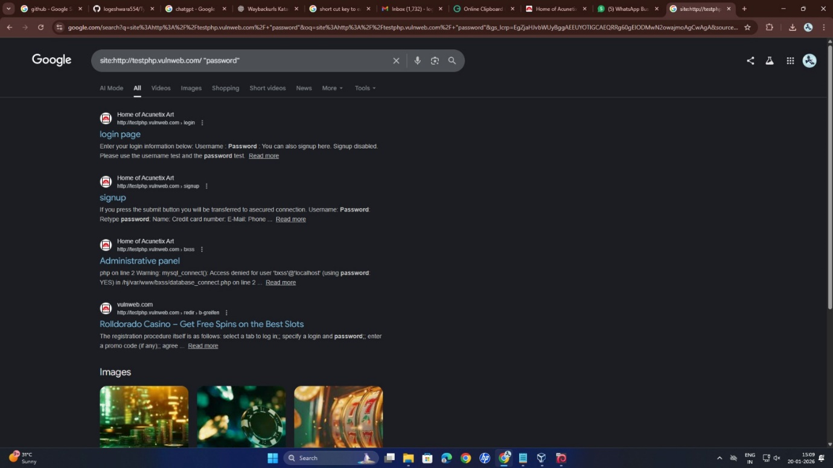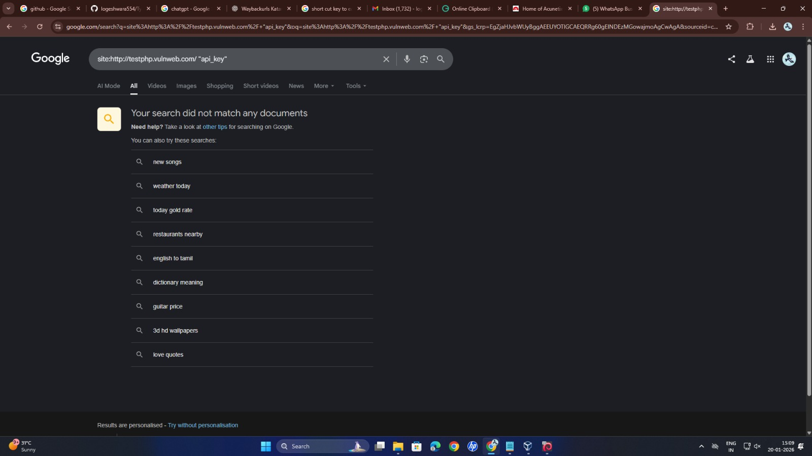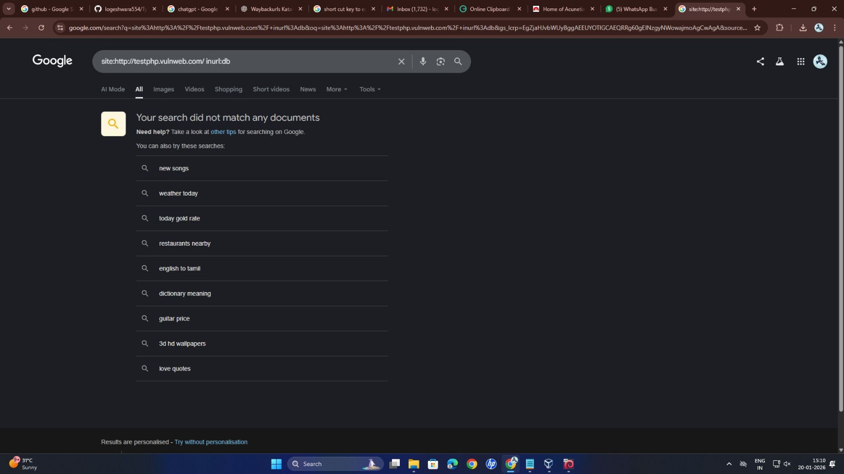

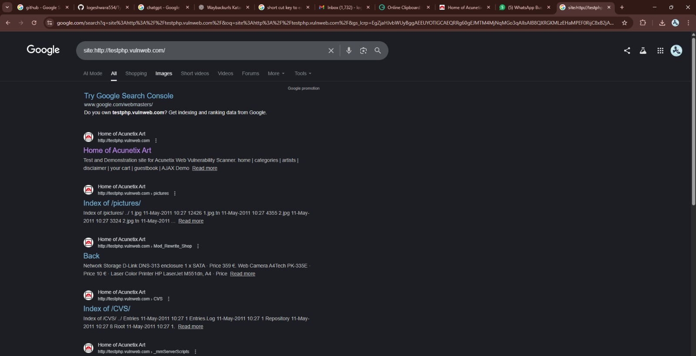

1. Review Webserver Metafiles for Information Leakage

View the Robots.txt file

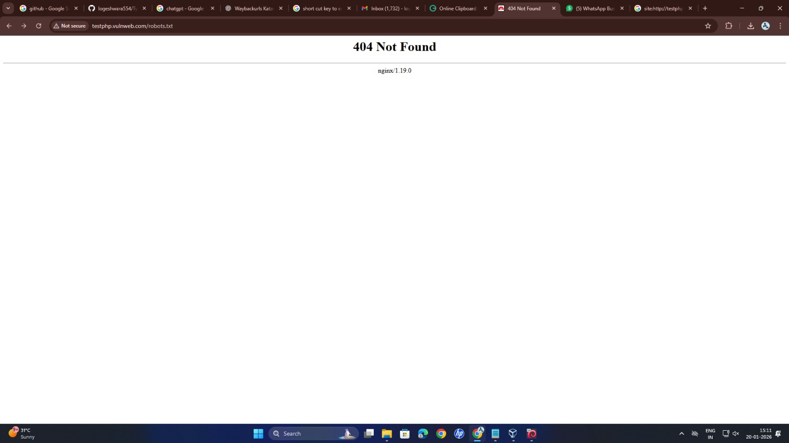

View the sitemap.XML file

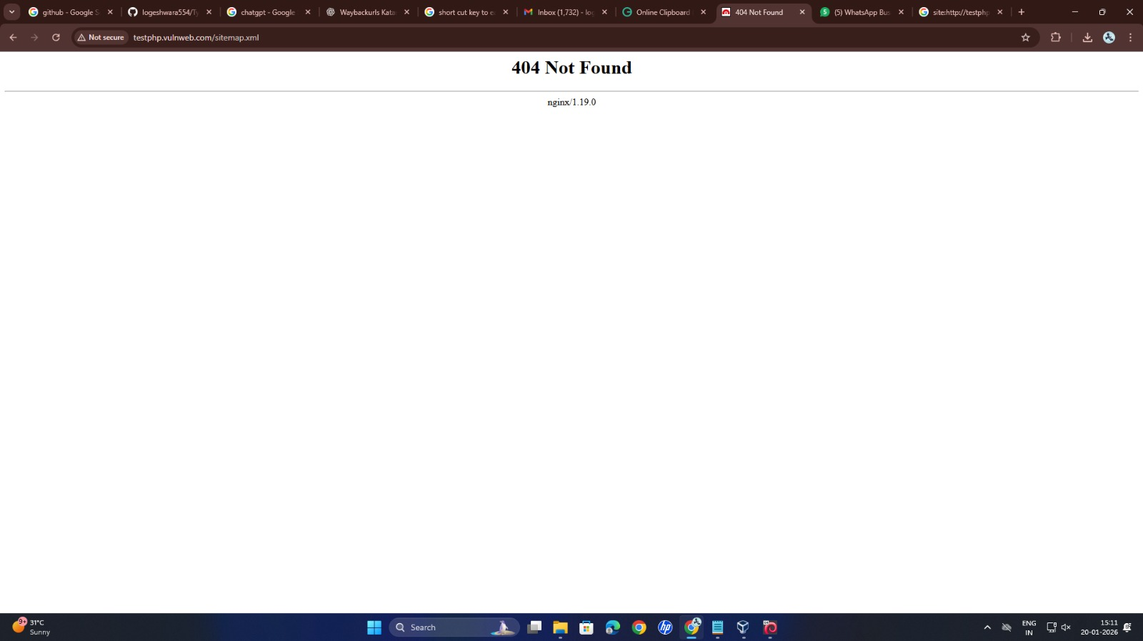

View the .htaccess file

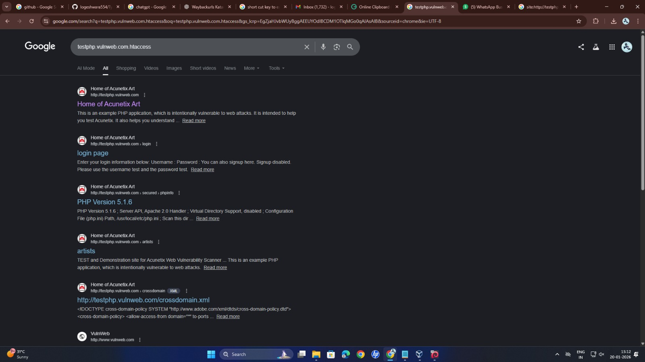

View the .git file

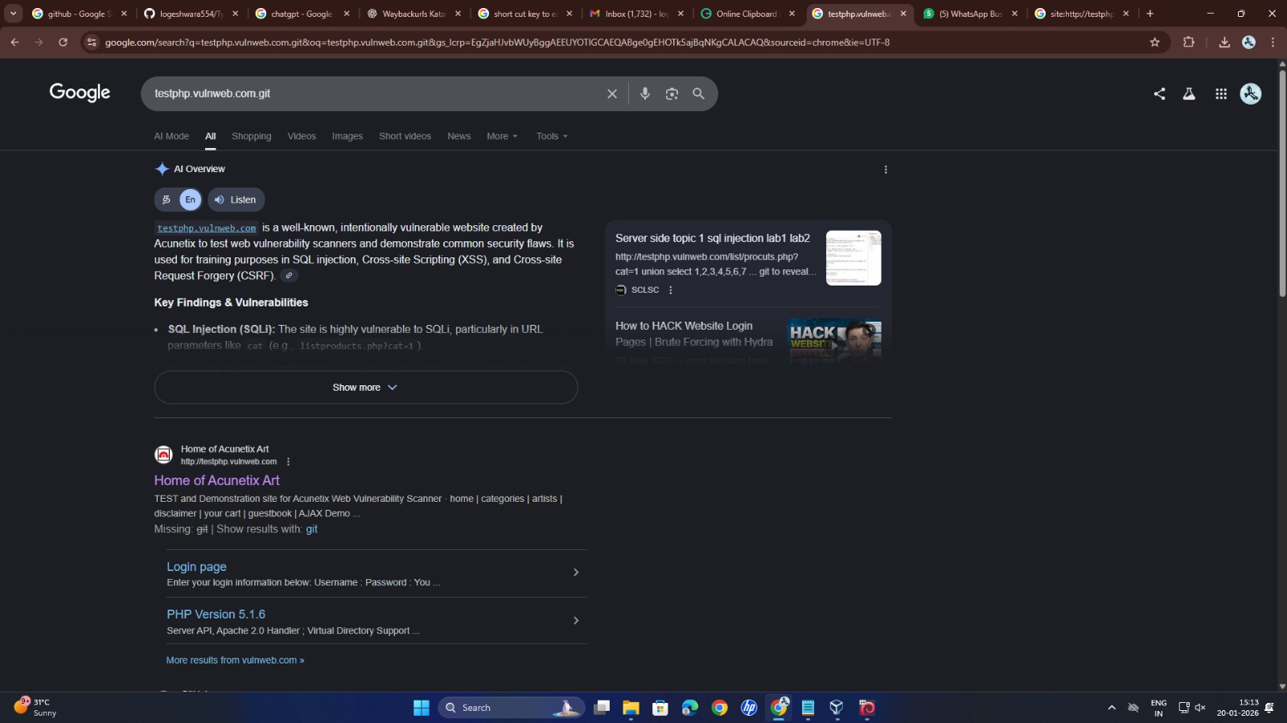

4.Email Security Record Enumeration

Perform a SPF lookup

Perform a Dmarc lookup

Peform a mta sts

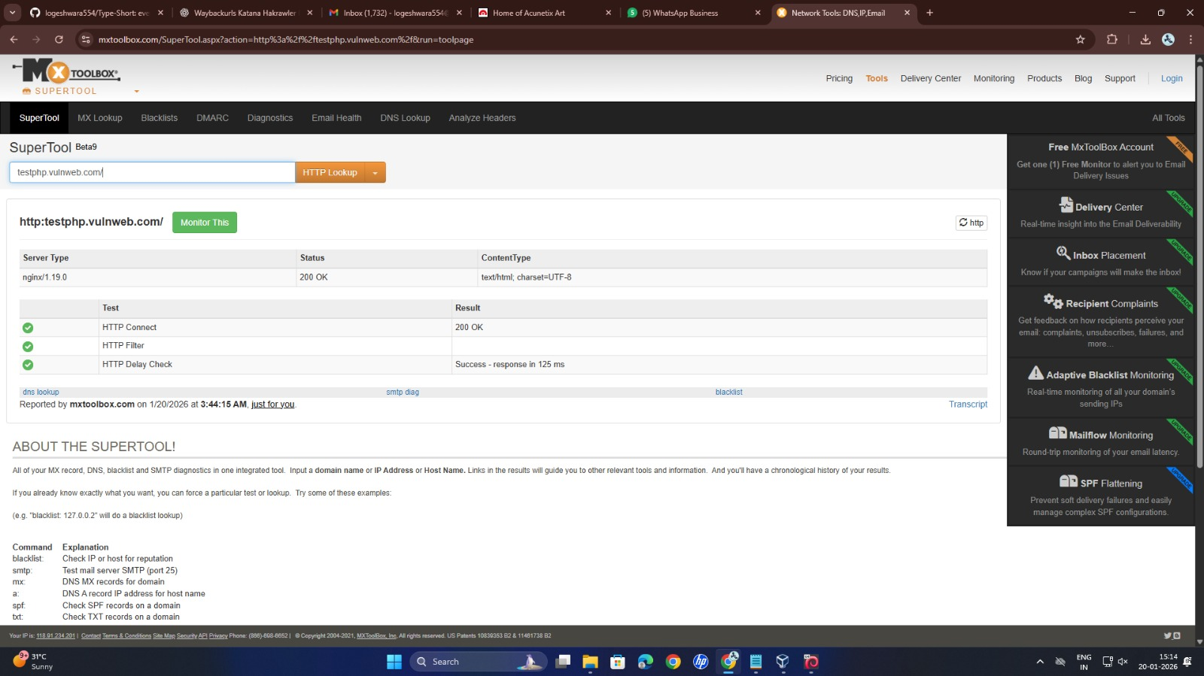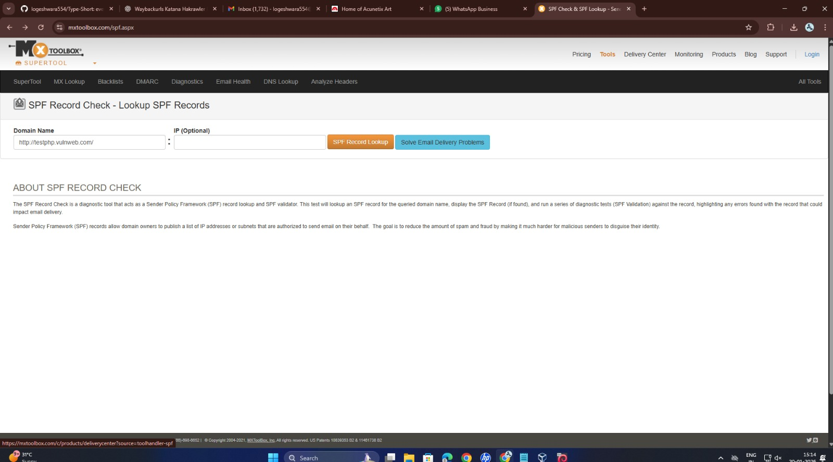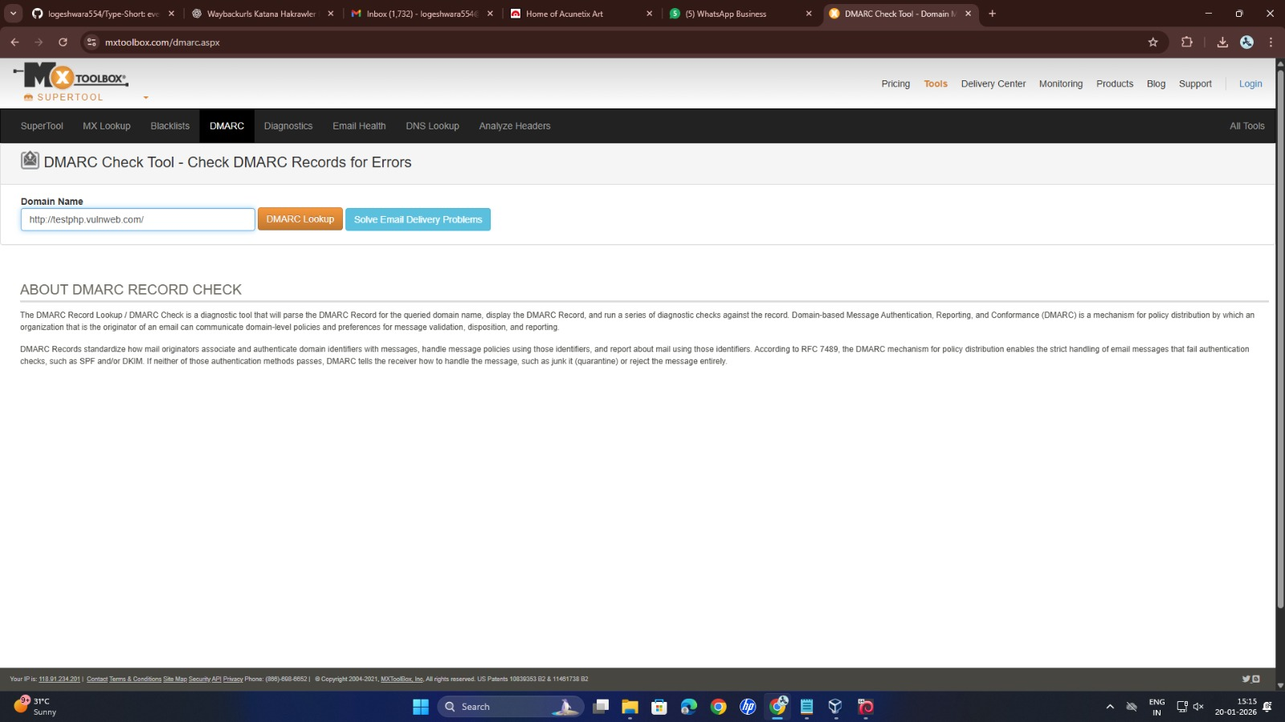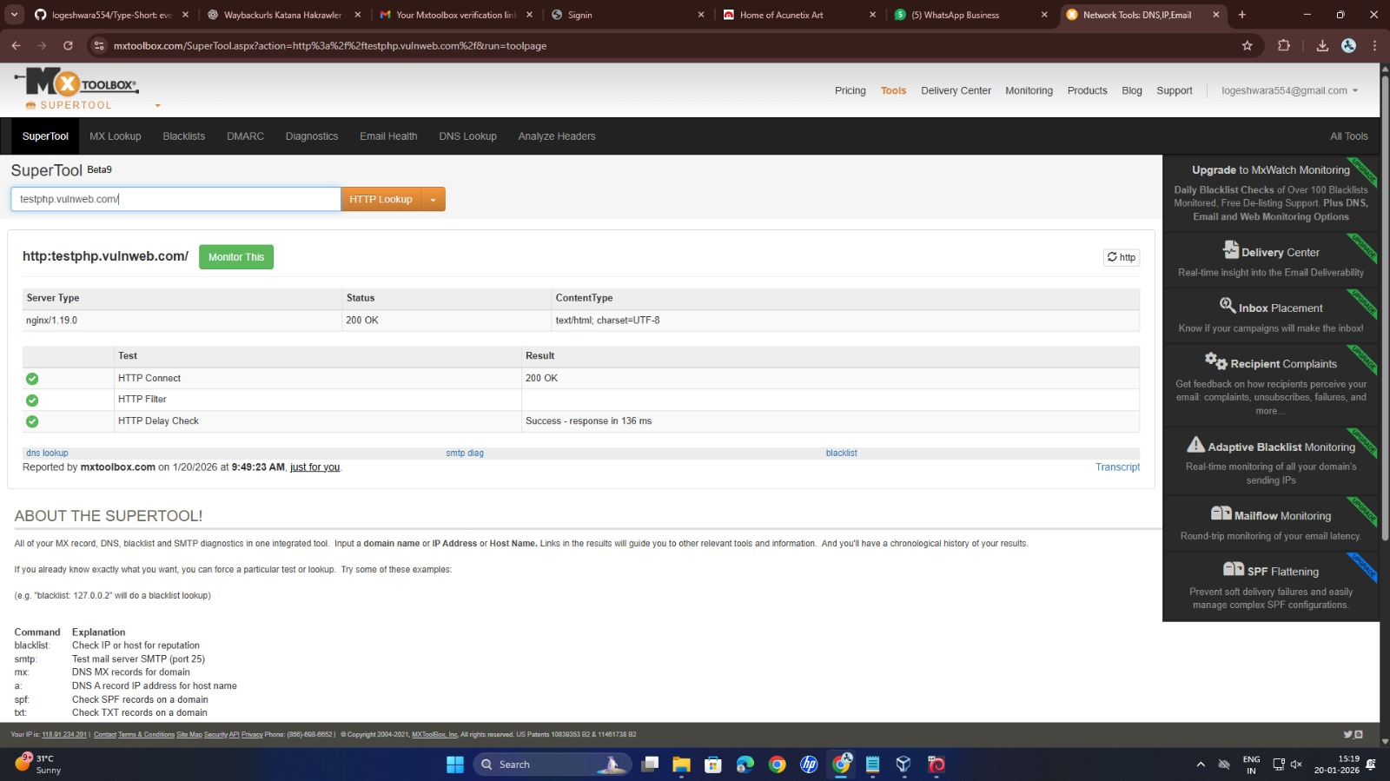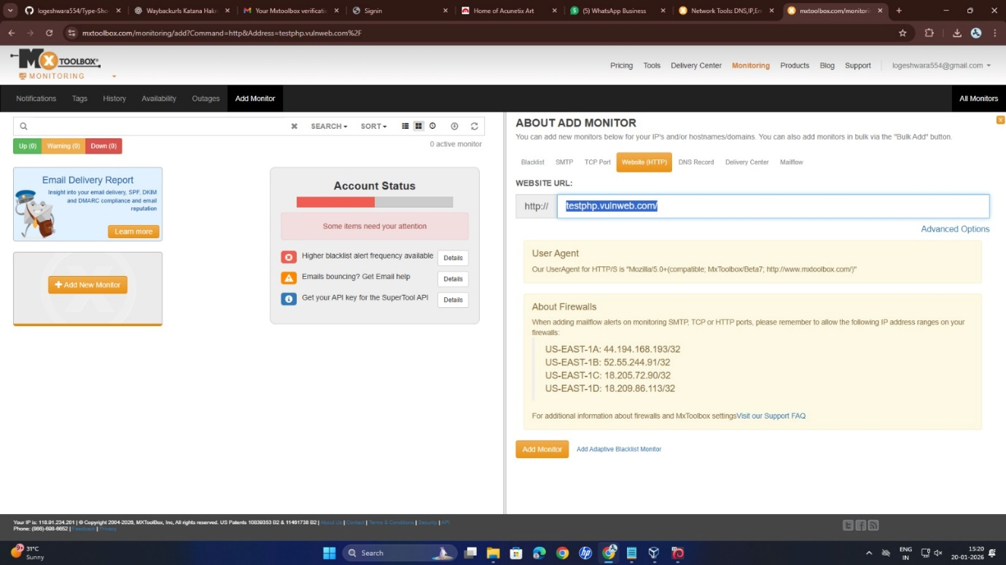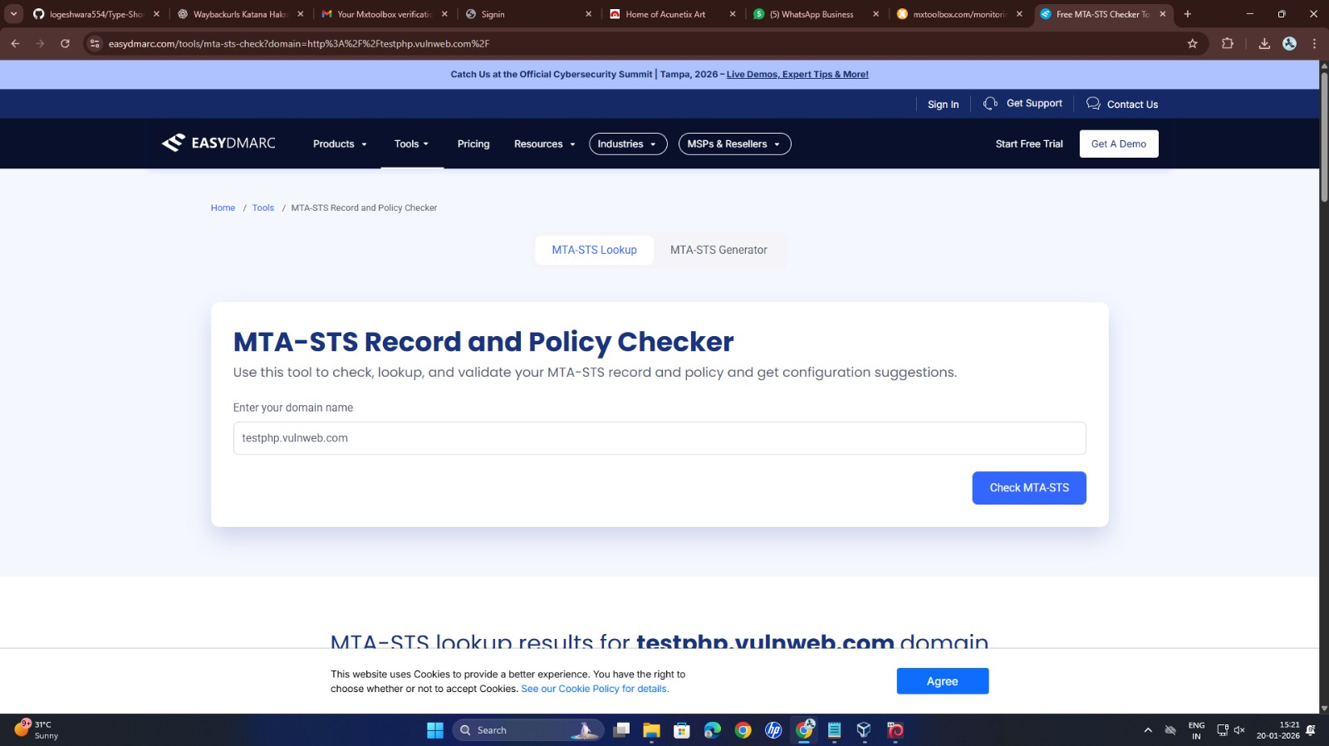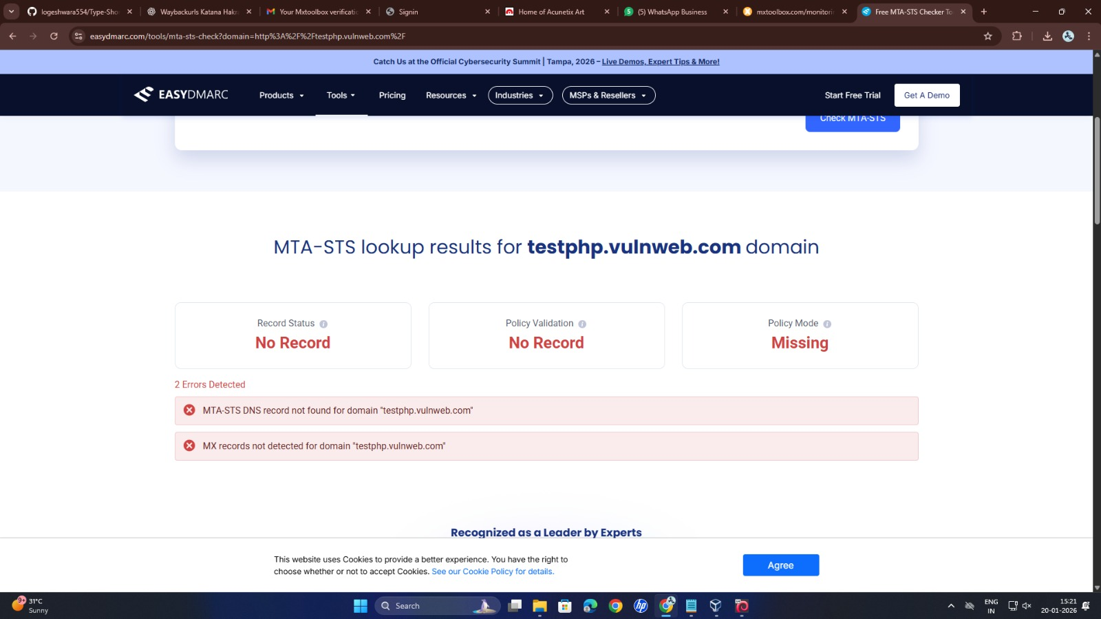

5. Review The Web Contents

Inspect the page source for sensitive info

Try to find Sensitive Javascript codes

Try to find any keys

Make sure the autocomplete is disabled

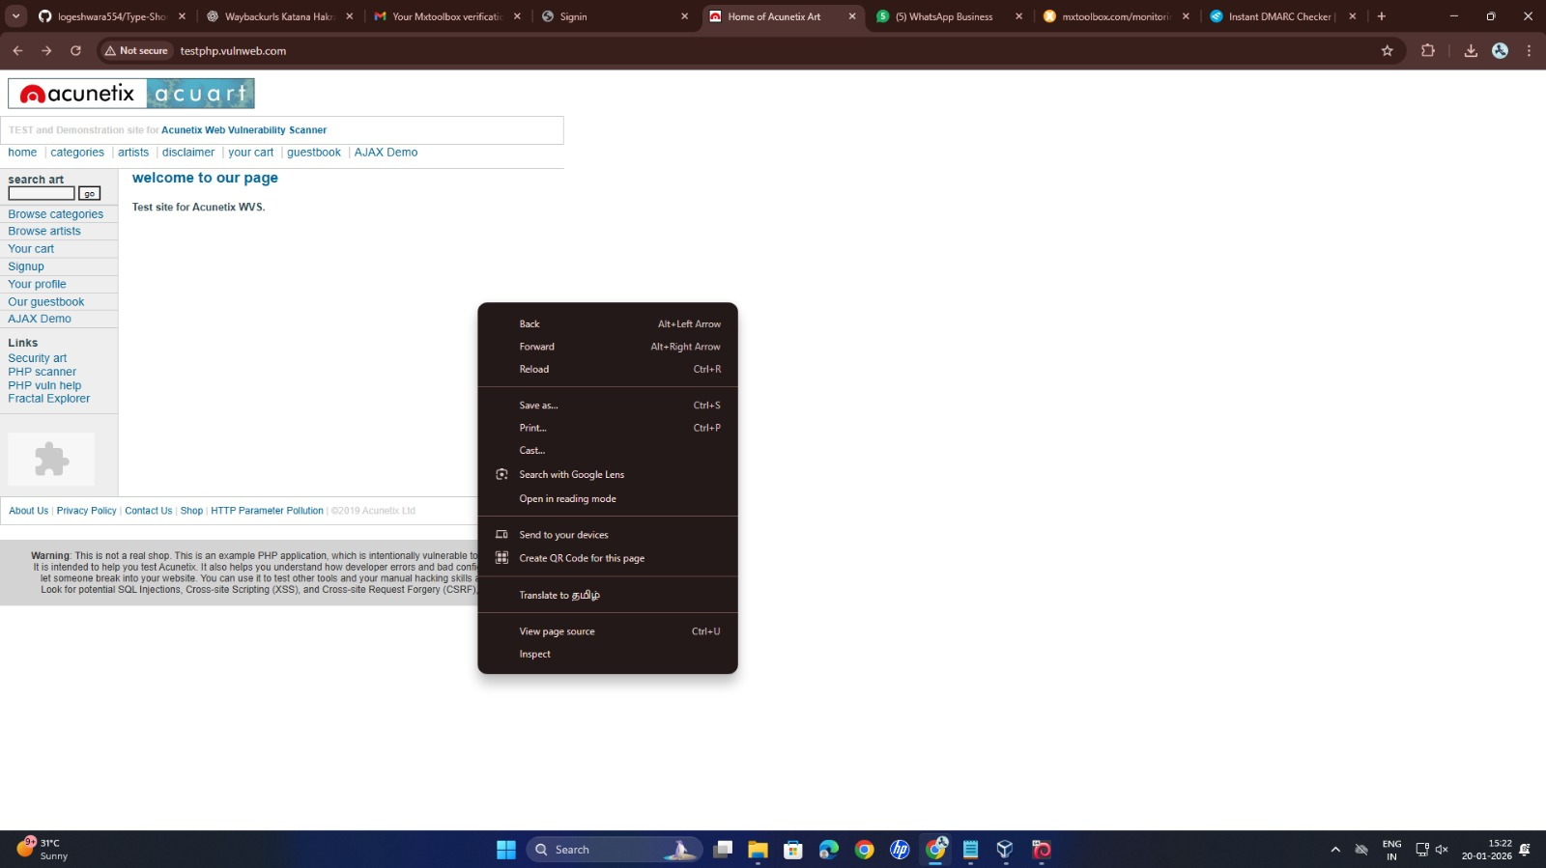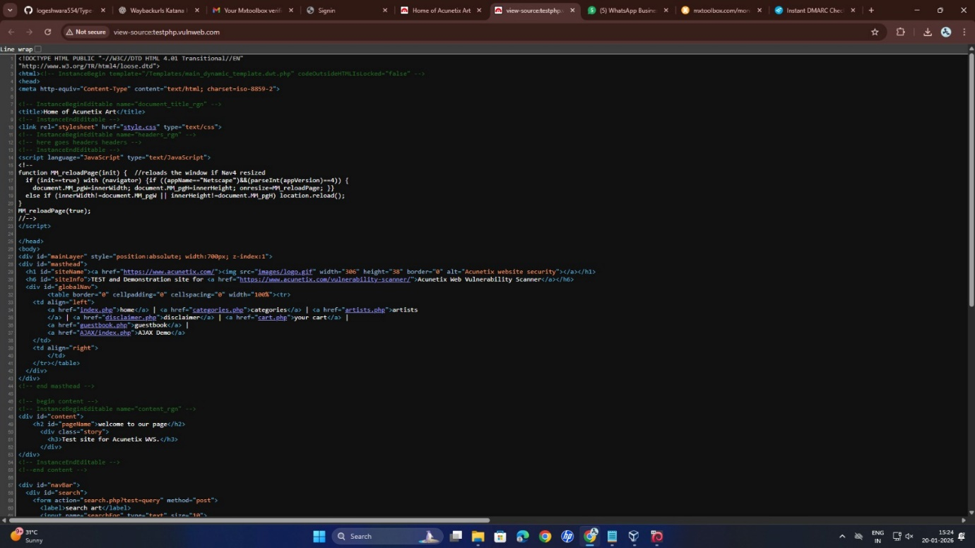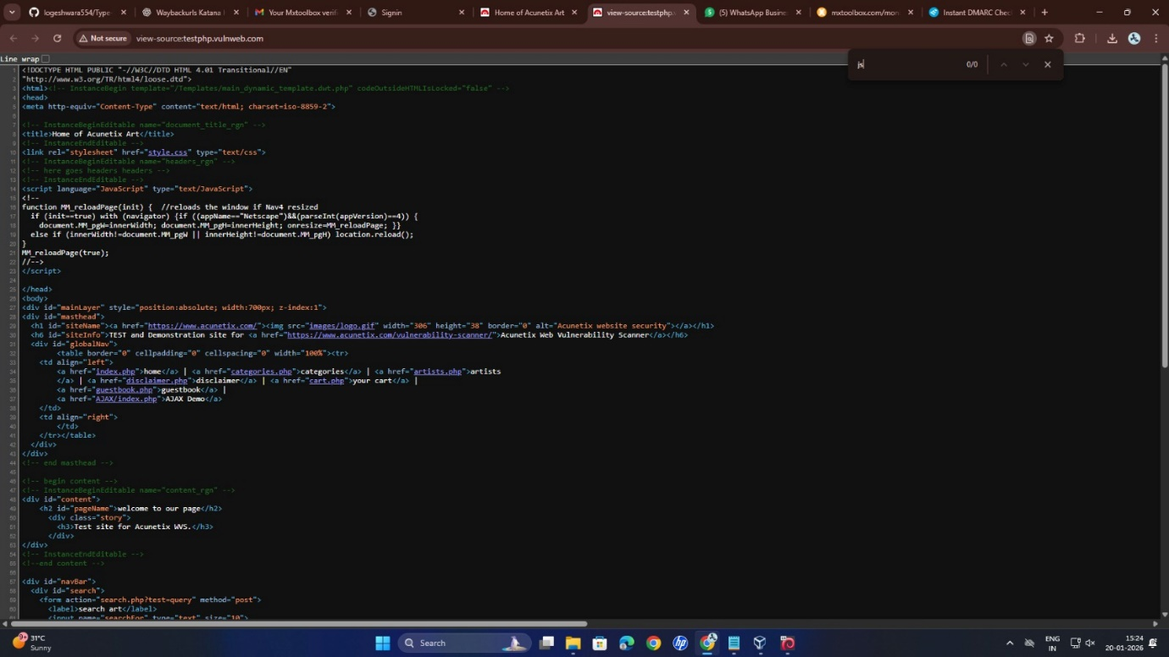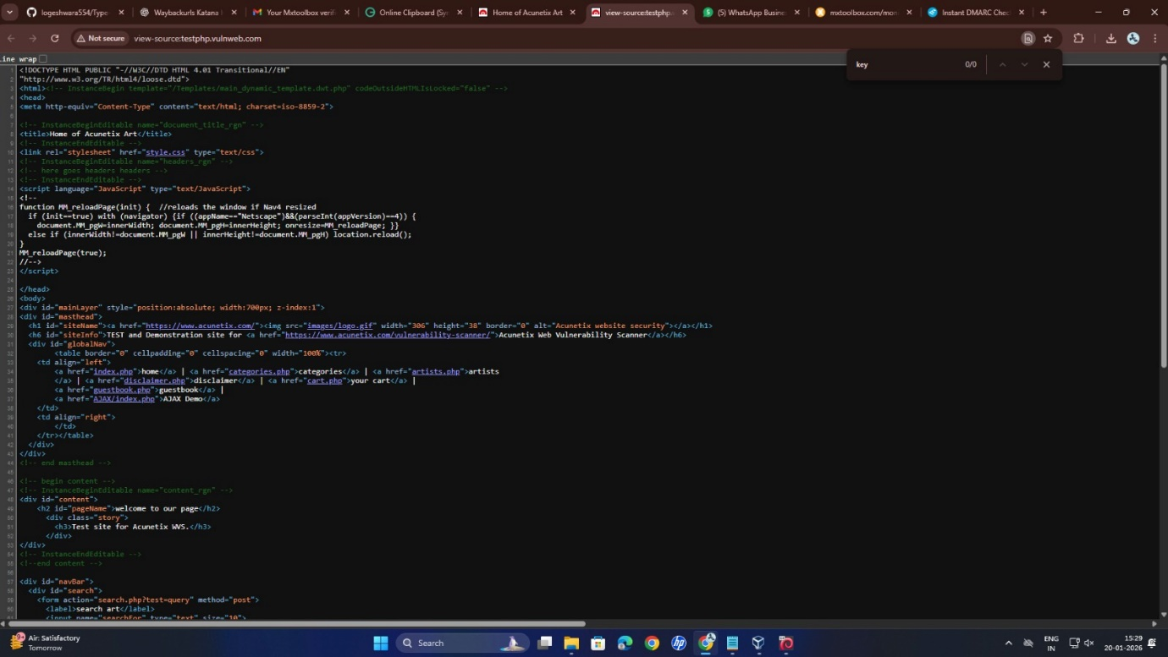

7. URL Gathering

Waybackurls

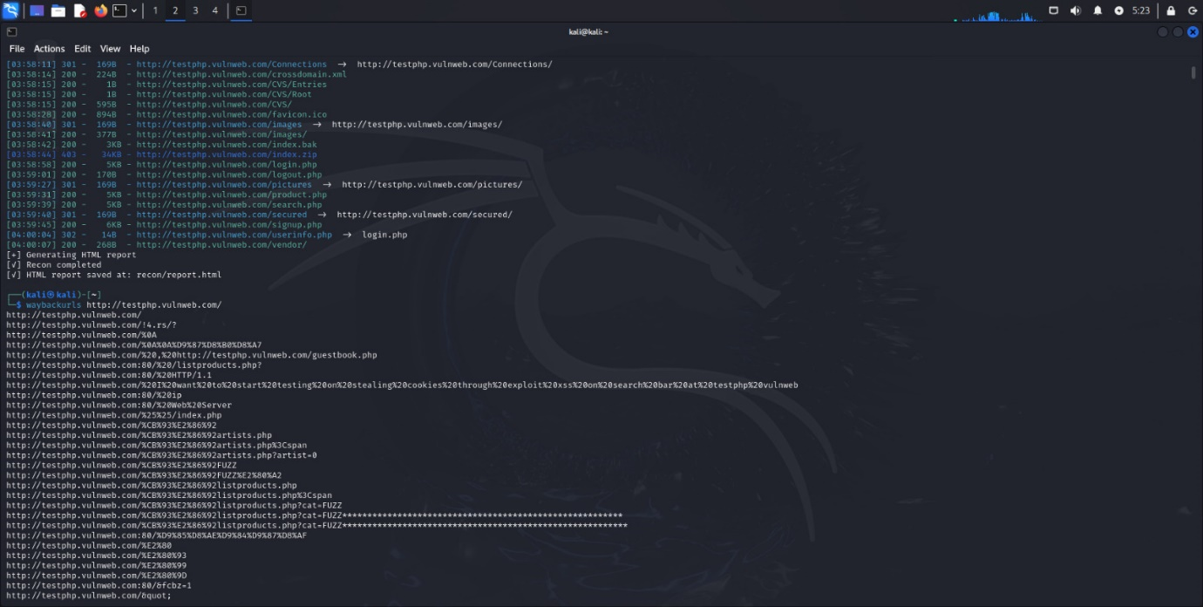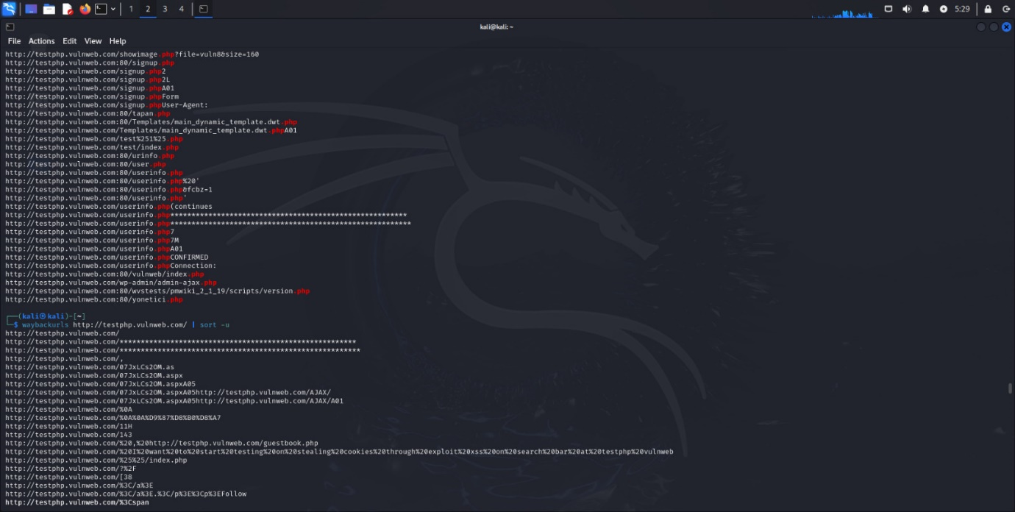

Katana

katana -u https://example.com

katana -u https://example.com -d 5

katana -u https://example.com -jc

katana -u https://example.com -fr

katana -u https://example.com -subs

katana -u https://example.com -silent

katana -u https://example.com -o katana.txt

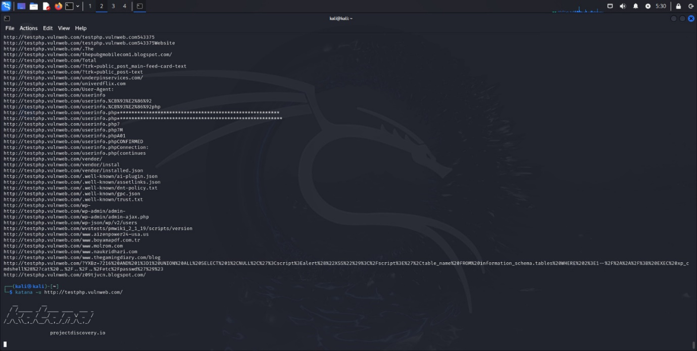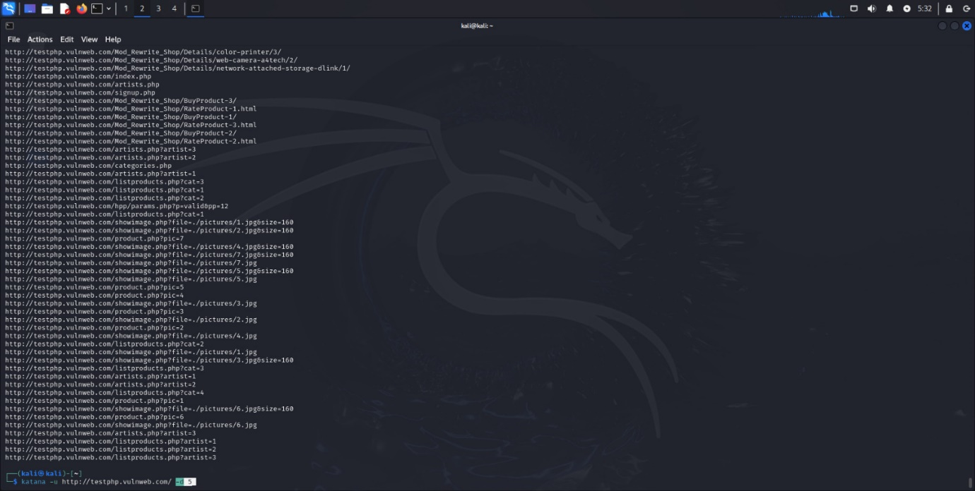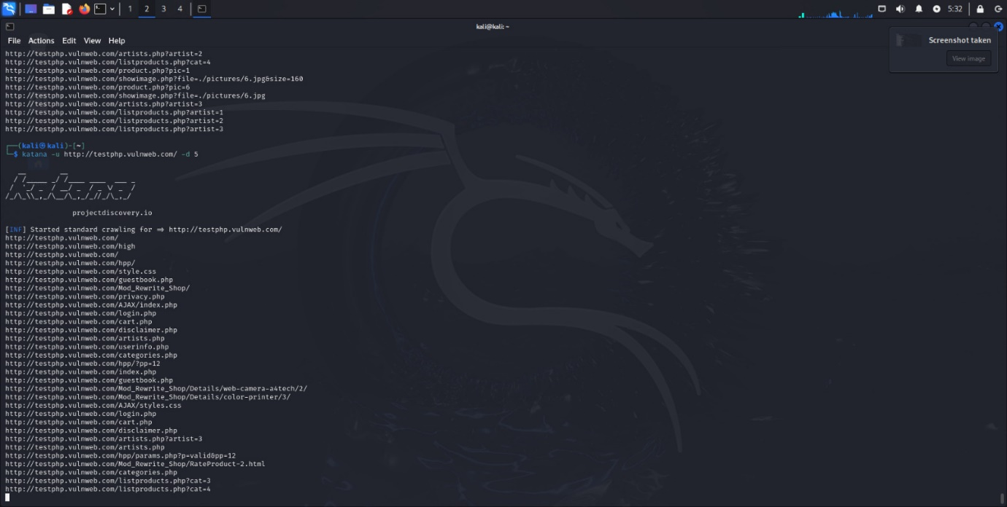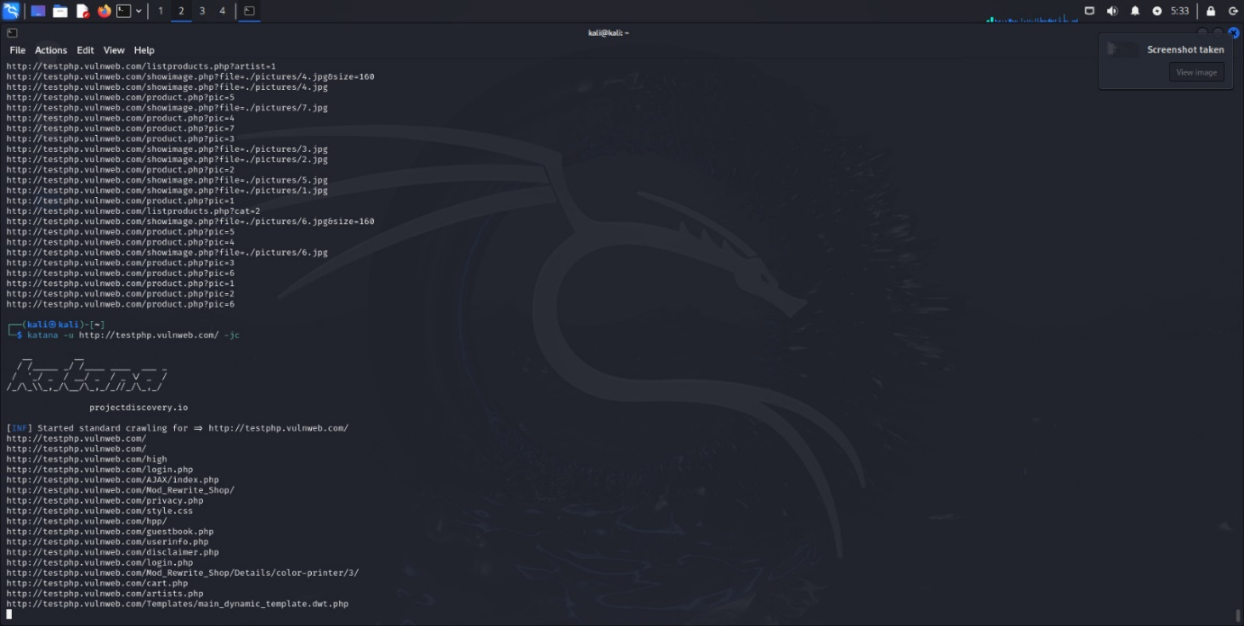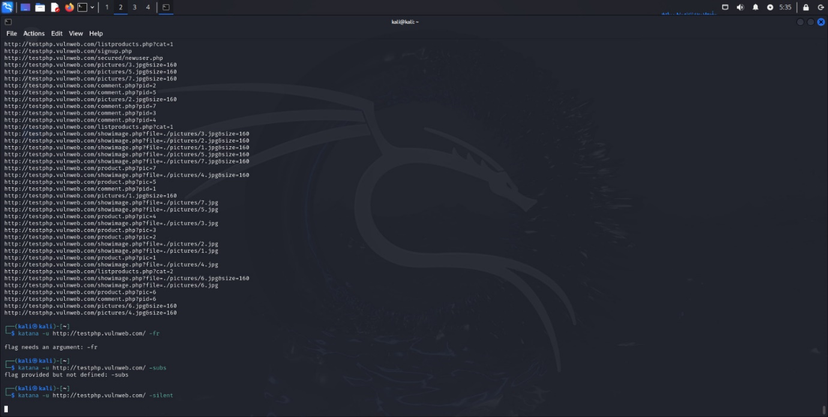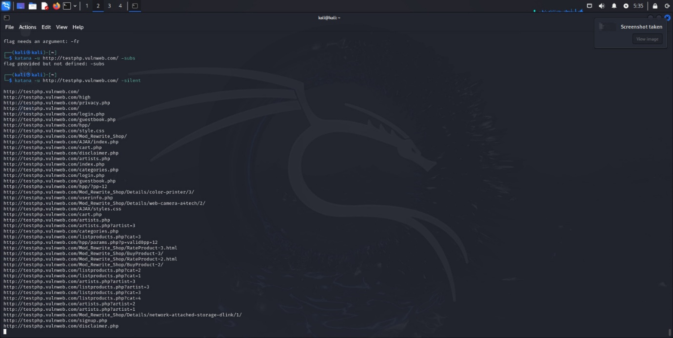

Hakrawler

echo https://example.com | hakrawler

echo https://example.com | hakrawler -d 3

echo https://example.com | hakrawler -js

echo https://example.com | hakrawler -subs

echo https://example.com | hakrawler -plain

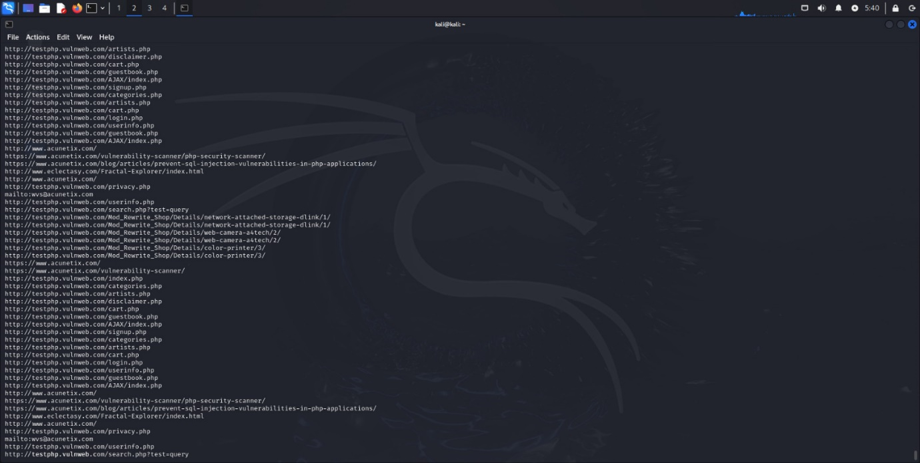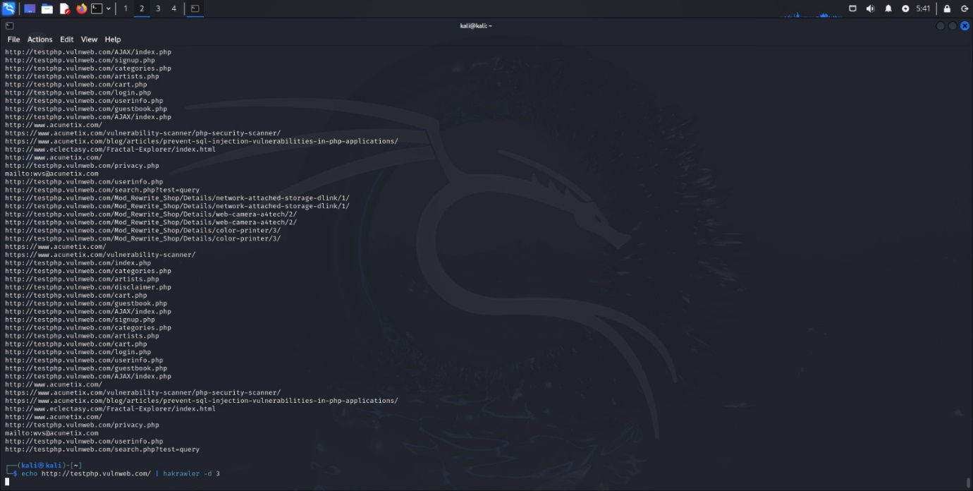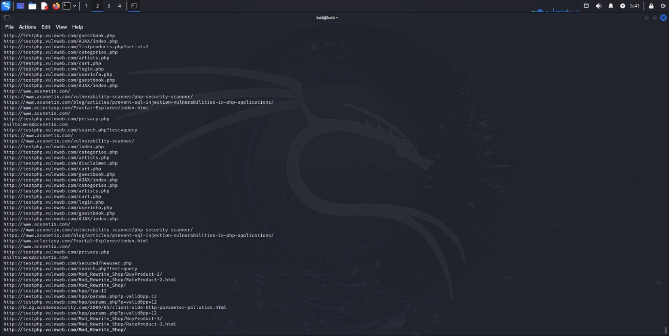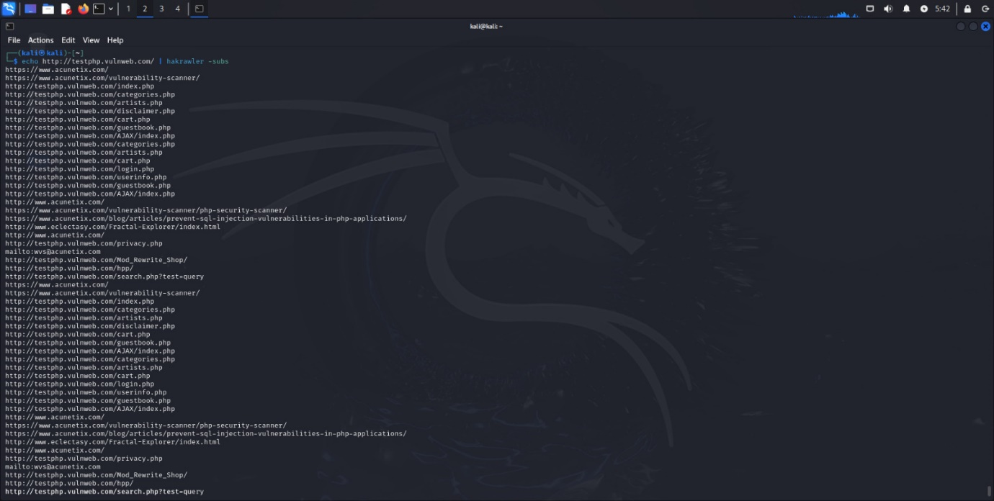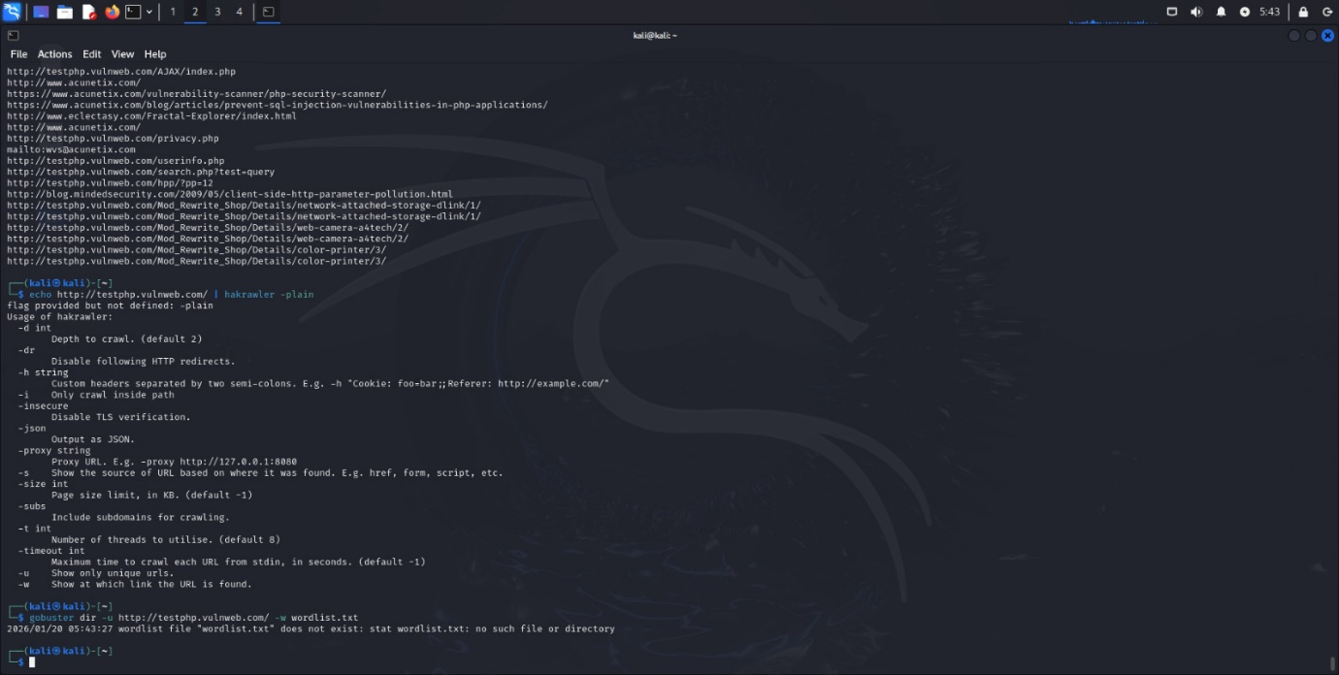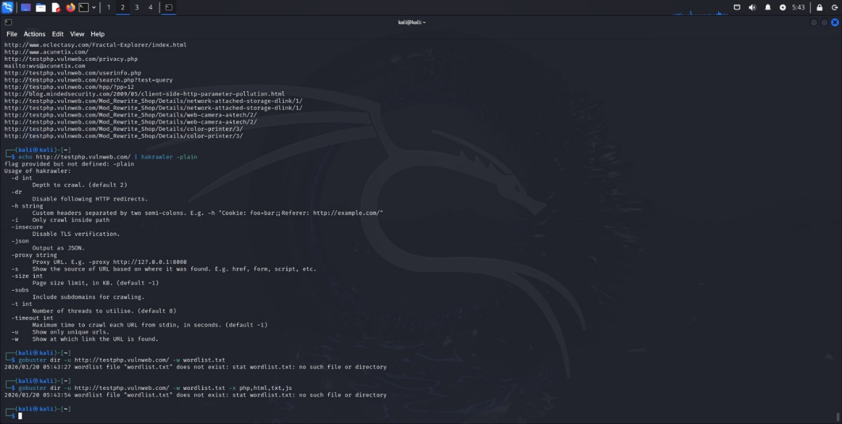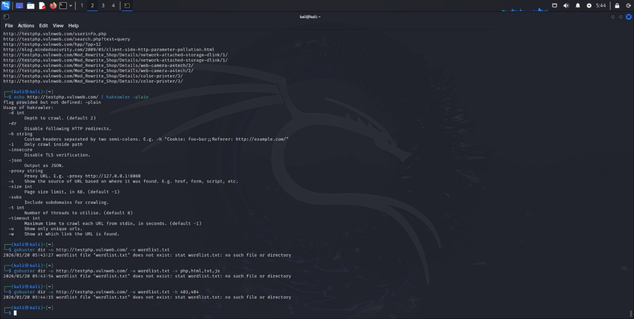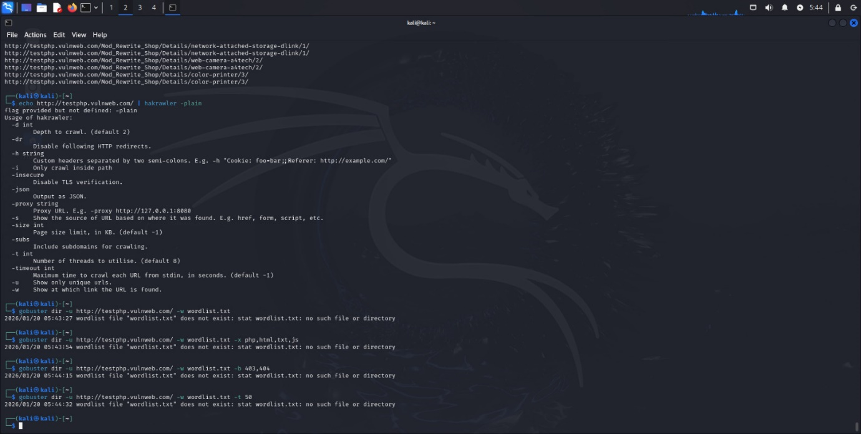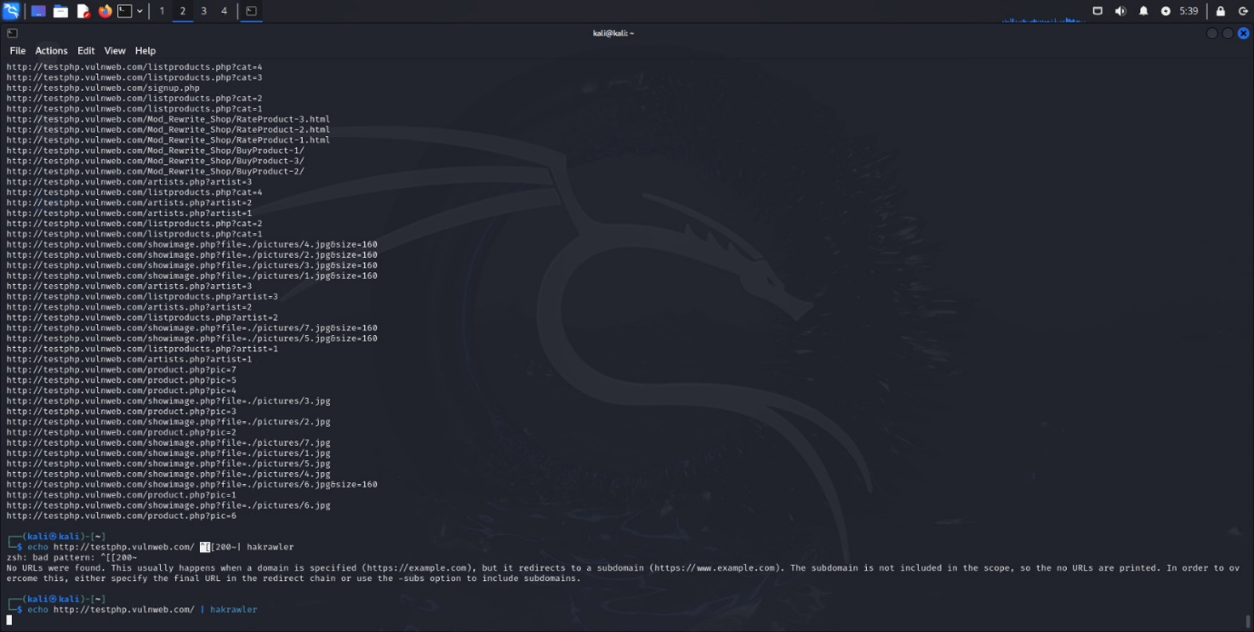

Gobuster

gobuster dir -u https://example.com -w wordlist.txt

gobuster dir -u https://example.com -w wordlist.txt -x php,html,txt,js

gobuster dir -u https://example.com -w wordlist.txt -b 403,404

gobuster dir -u https://example.com -w wordlist.txt -t 50

gobuster dns -d example.com -w subs.txt

gobuster vhost -u https://example.com -w vhosts.txt

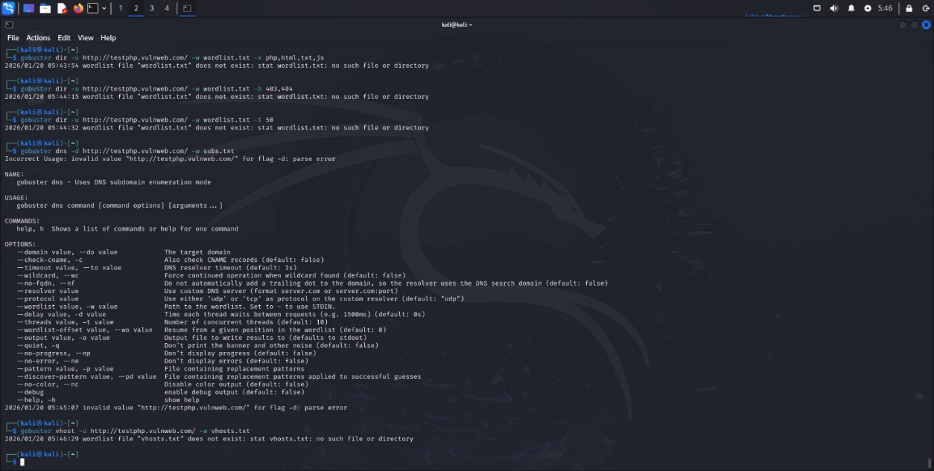

Ffuf

ffuf -u https://example.com/FUZZ -w wordlist.txt

ffuf -u https://example.com/FUZZ -w wordlist.txt -e .php,.html,.txt

ffuf -u https://example.com/FUZZ -w wordlist.txt -mc 200,301,302

ffuf -u https://example.com/FUZZ -w wordlist.txt -fs 4242

ffuf -u https://example.com/login -X POST -d "user=FUZZ&pass=test" -w users.txt

ffuf -u https://example.com -H "X-Forwarded-For: FUZZ" -w ips.txt

ffuf -u https://example.com/FUZZ -w wordlist.txt -rate 10

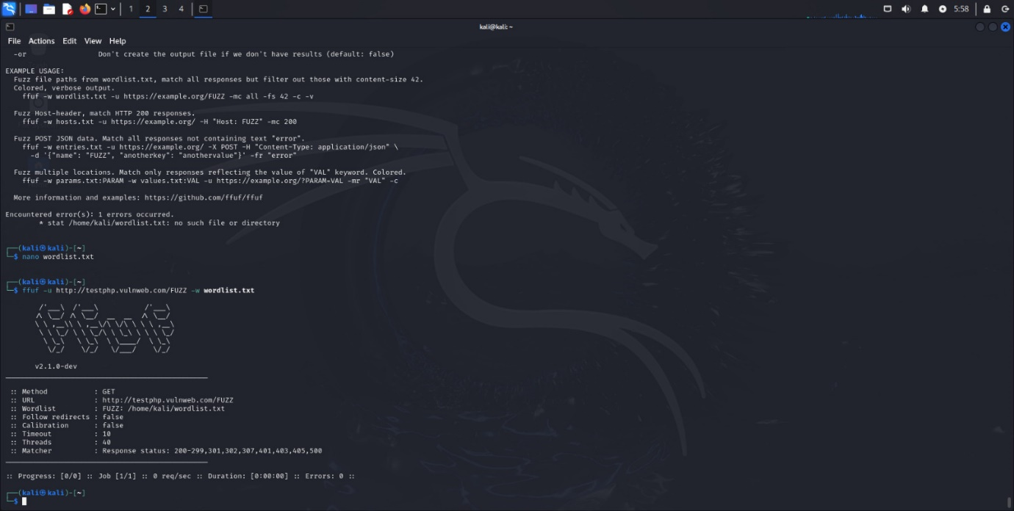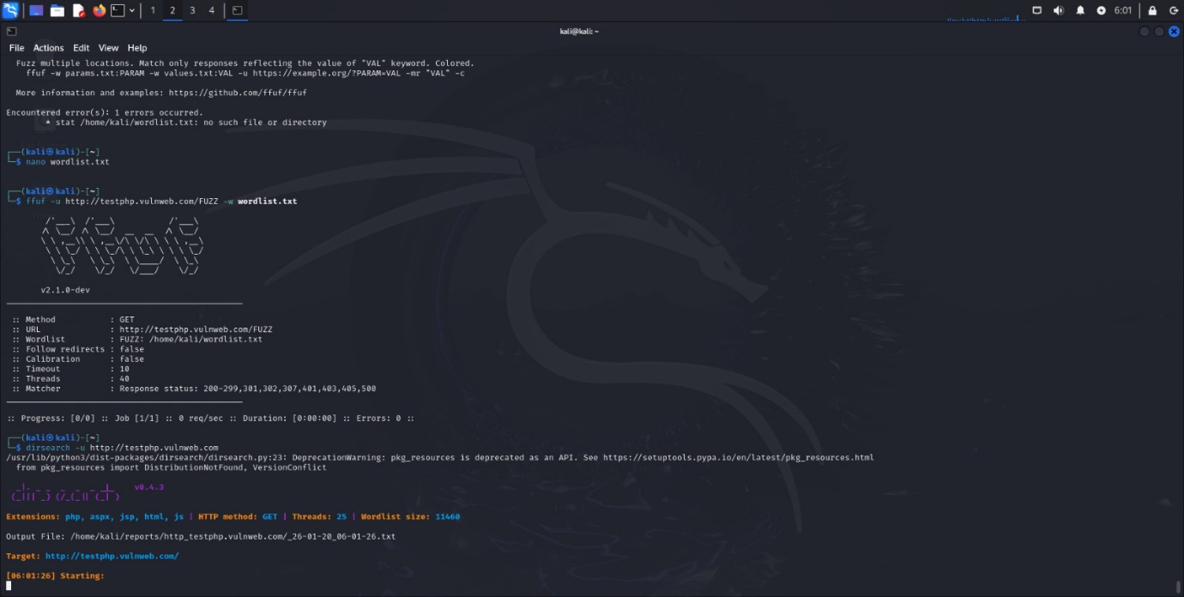

Dirsearch

dirsearch -u https://example.com

dirsearch -u https://example.com -e php,html,js,txt

dirsearch -u https://example.com -r

dirsearch -u https://example.com --exclude-status 404

dirsearch -u https://example.com --random-agent

dirsearch -u https://example.com -t 50

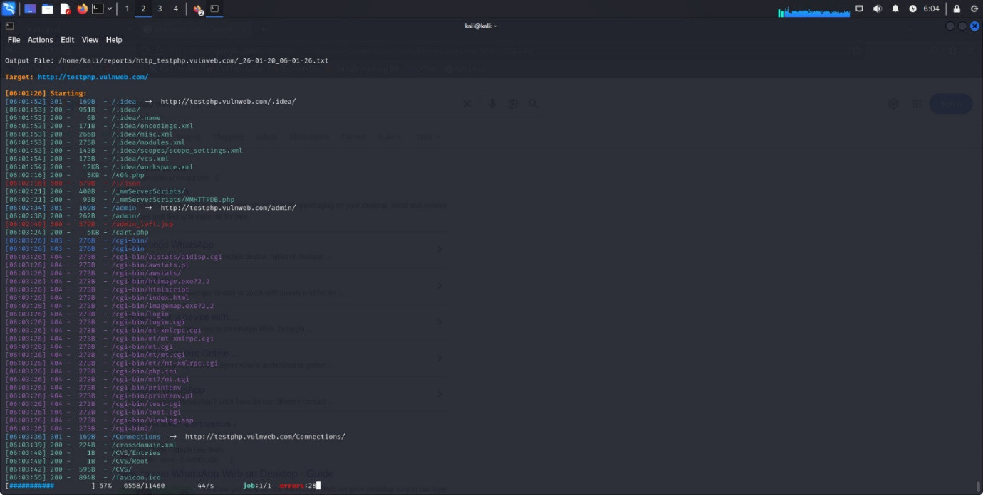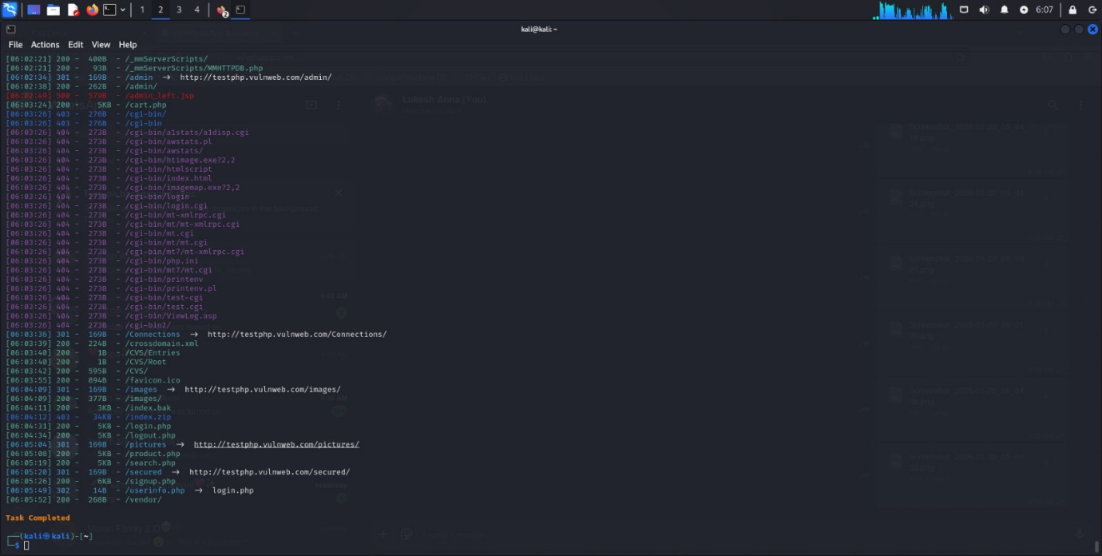

Httpx

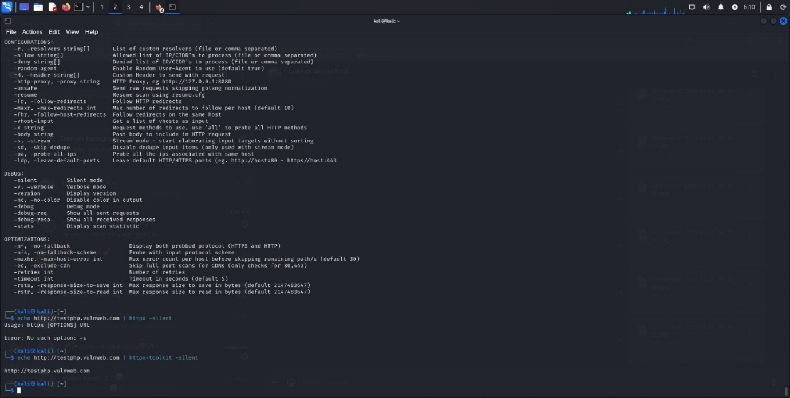

Nmap

nmap example.com

nmap -sV example.com

nmap -O example.com

nmap -A example.com

nmap -p- example.com

nmap -T4 example.com

nmap --script vuln example.com

nmap example.com -oN output.txt

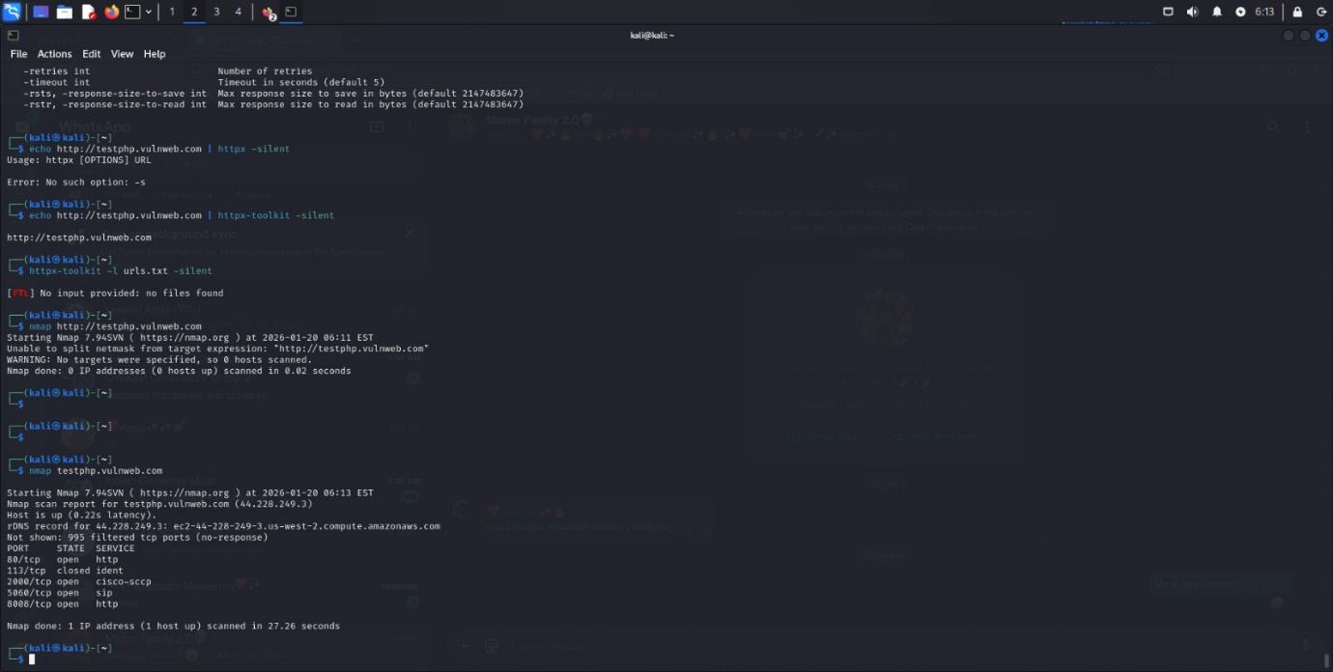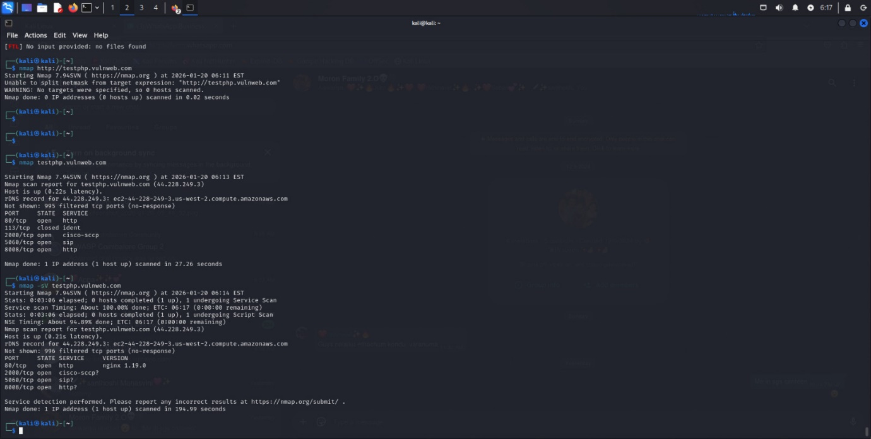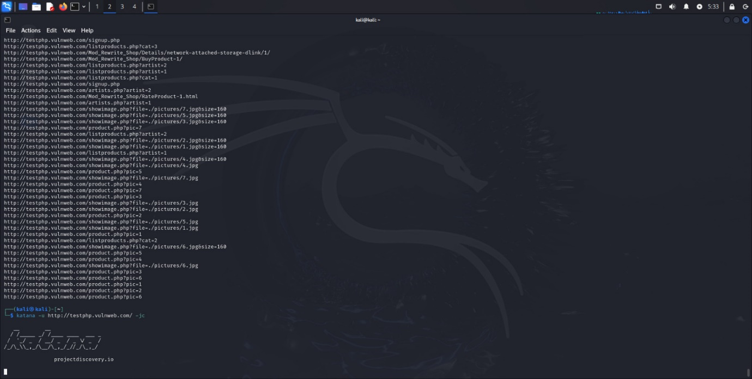

8. Server Version Disclosure

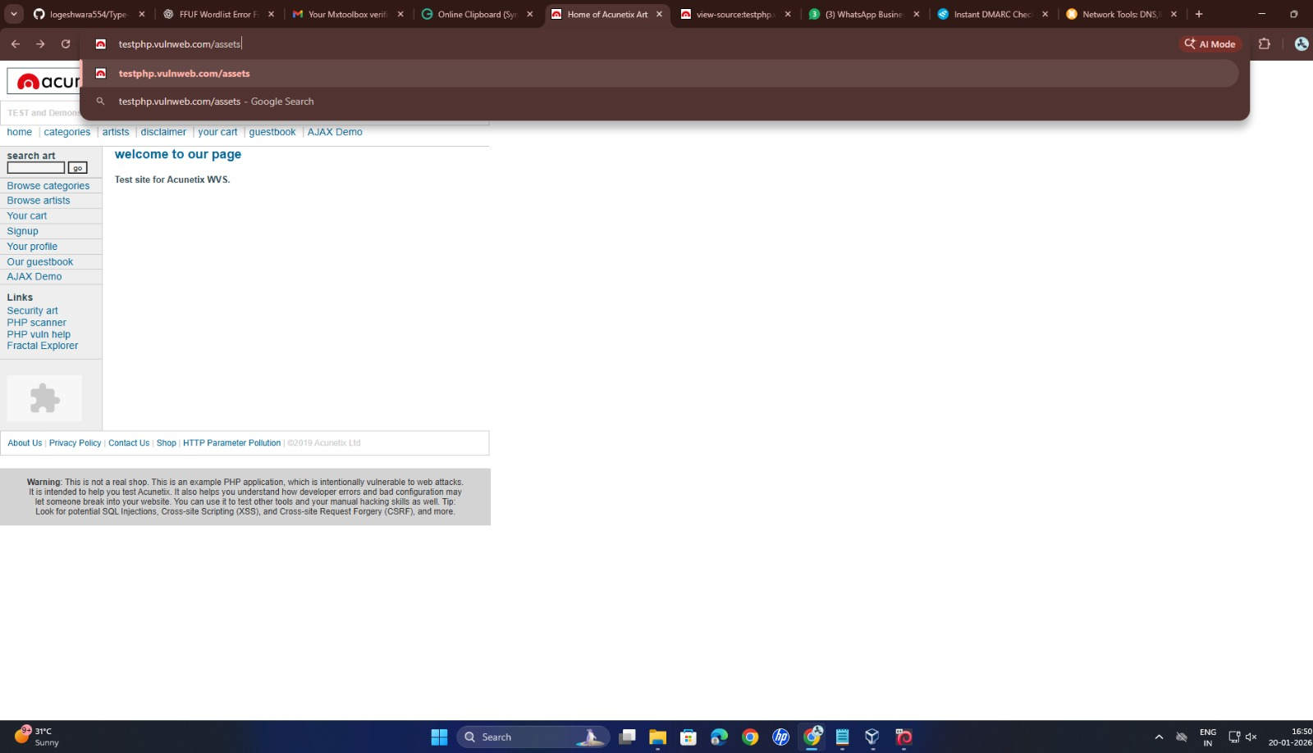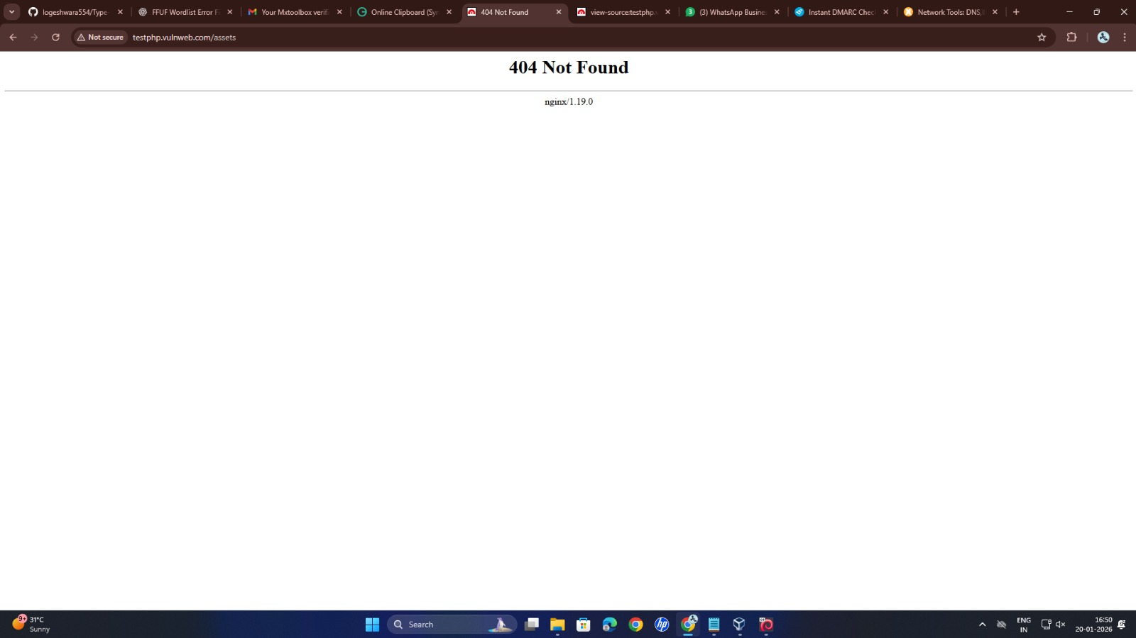

9. Autocomplete Enabled on Sensitive Fields

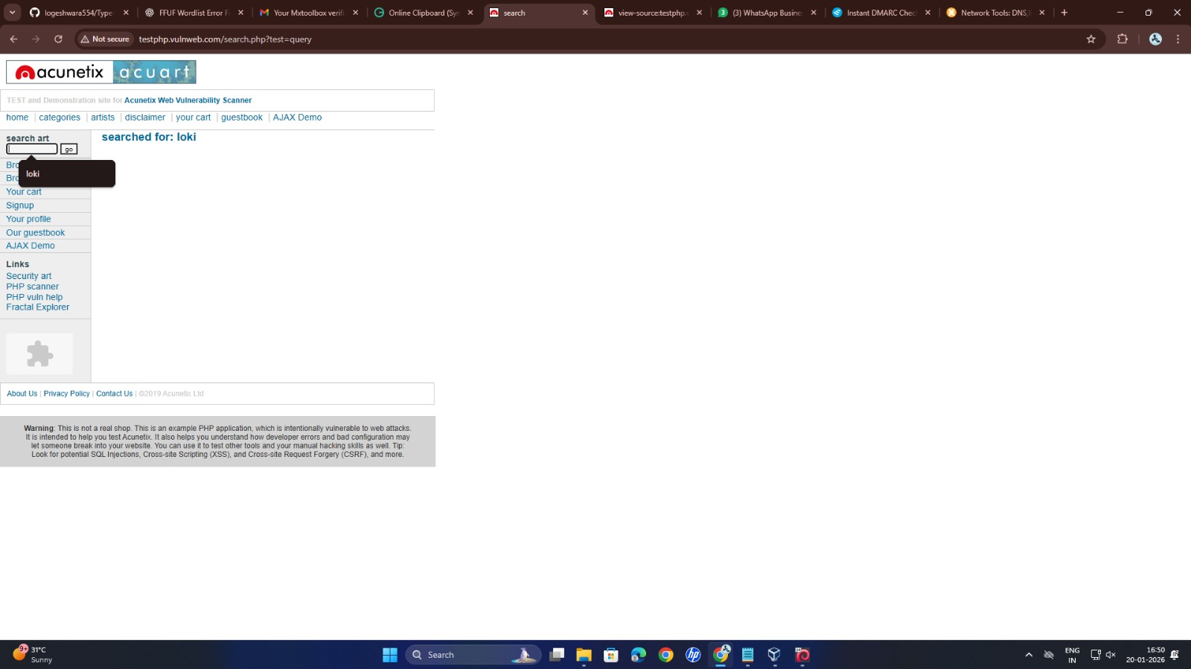

10. SSL/TLS Weakness

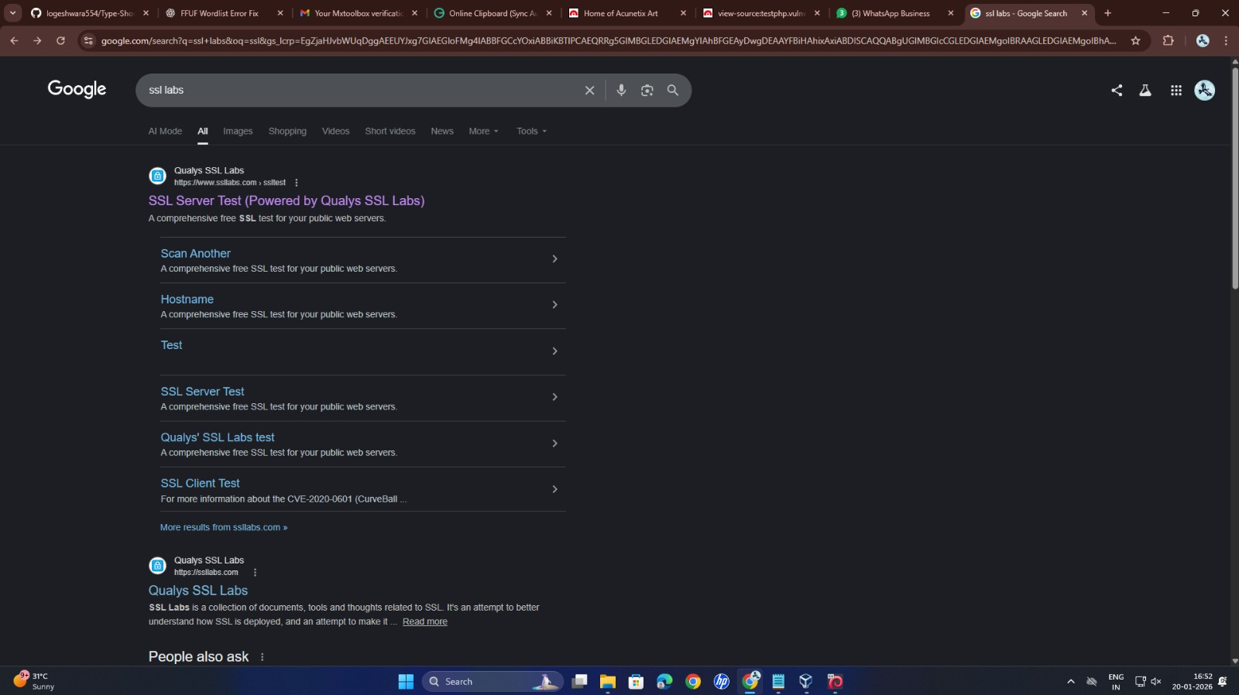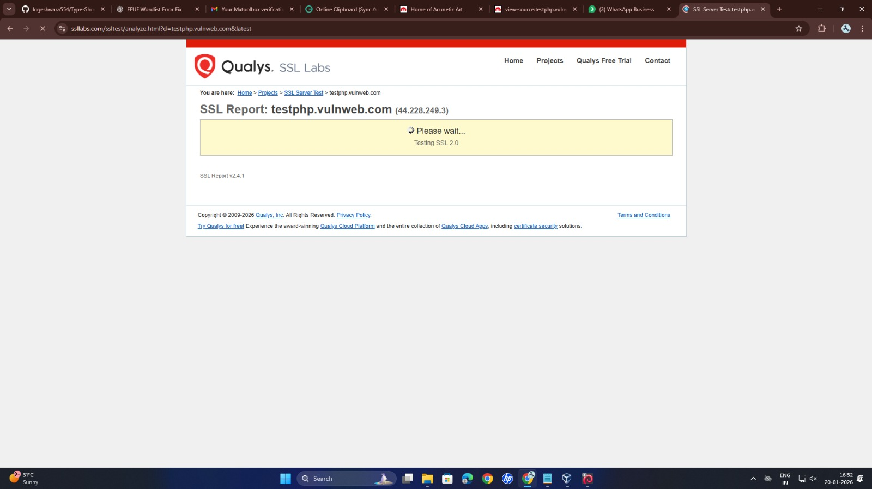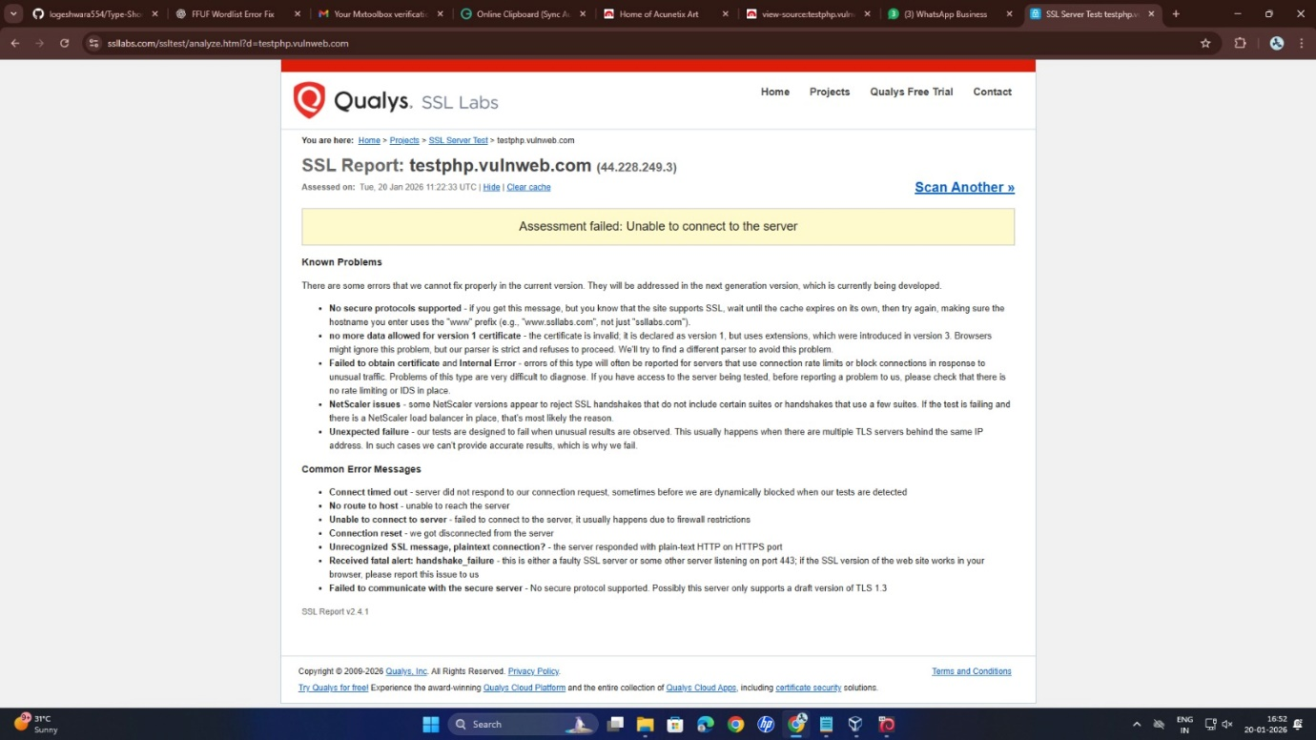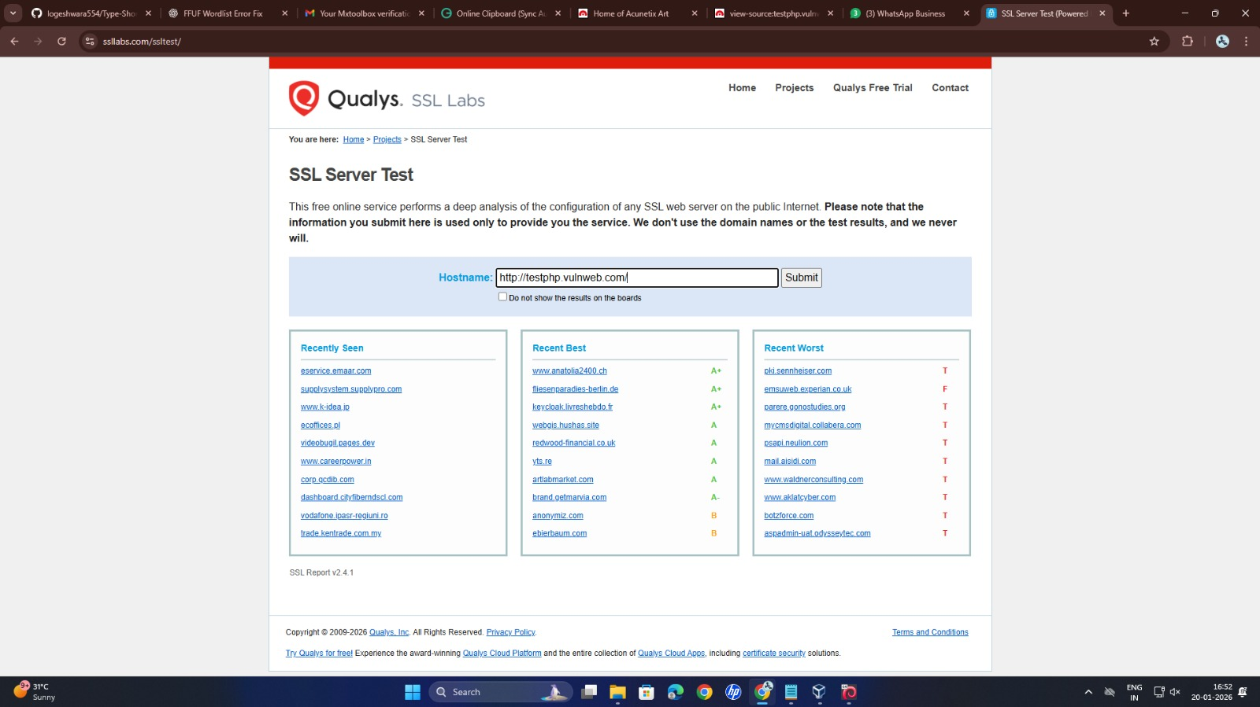

11. Clickjacking

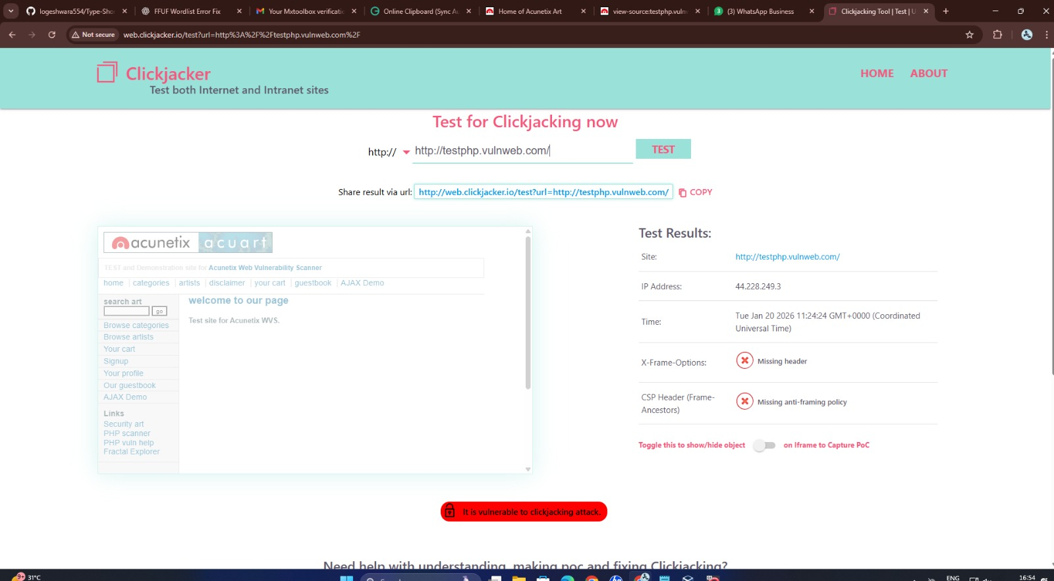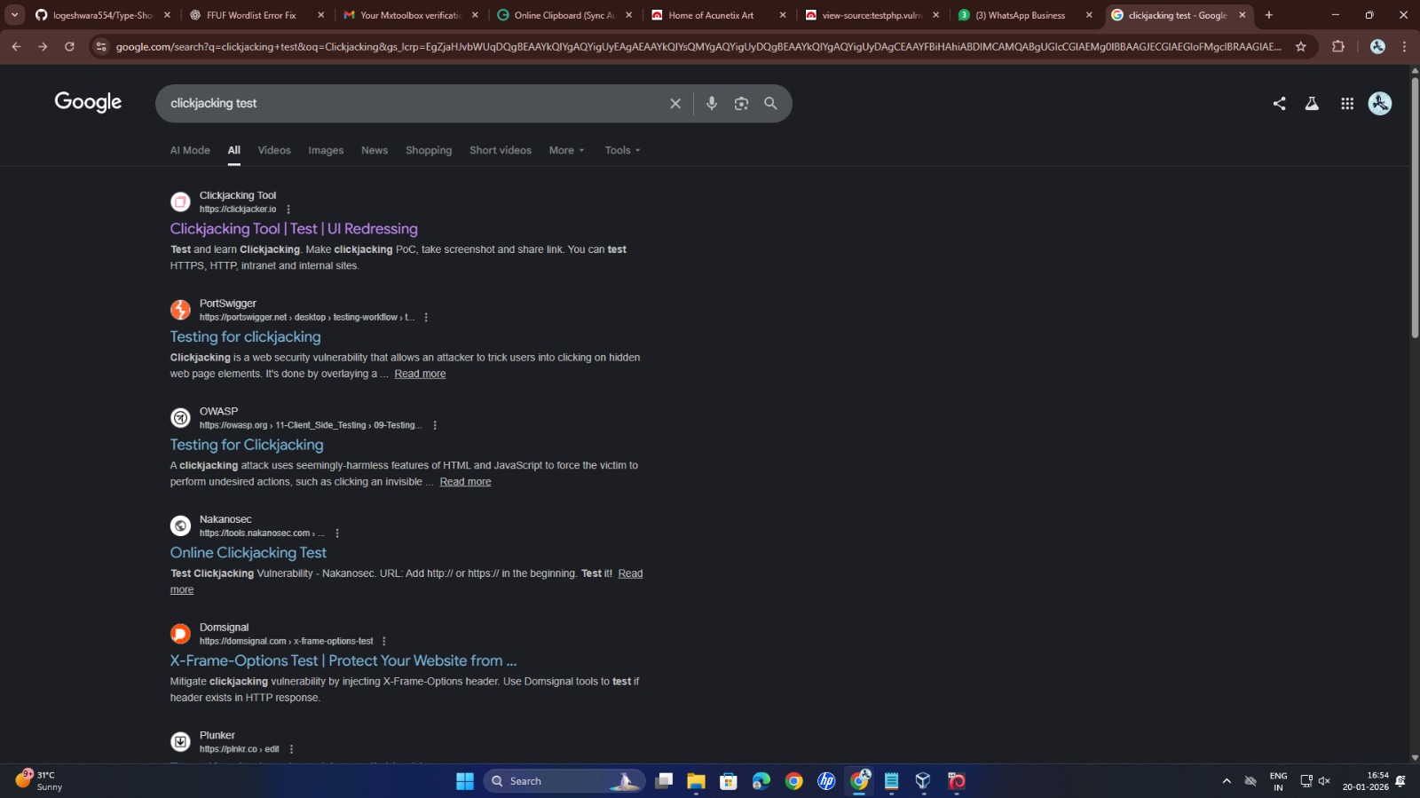

12. Security Headers

